SUPPLEMENTARY DETAILS

Table of Contents
1) General information | S1
2) Synthetic procedures | S2
3) Characteristic data for synthetic compounds | S3
4) Spectrum details for active compounds | S4

S1: GENERAL INFORMATION

The starting reactants of chemical compounds, reagents and solvent were procured from Sigma Aldrich, Himedia Ltd and Merck Ltd, those were HPLC graded components. The evaluation of melting point for synthesised compounds were performed by digital melting point apparatus by open capillary approach. The chromatogram for synthesised compounds were performed by Silica gel G TLC plates (Merck Ltd) and it was detected by iodine chamber. Further various spectroscopic techniques were utilized for characterisation of synthesised compounds such as λ max (Schimadzu Ultraviolet spectrometer), IR spectrum (Schimadzu FT-IR spectrophotometer) on KBr pellets, elemental analysis (CHNO Analyser), mass spectrum (HRMS mass spectrometer) and ¹HNMR spectrum (FT-NMR 500 MHz spectrometer) were evaluated from Indian institute of technology, Chennai and VIT university, Vellore.

S2: Synthetic procedures

First Step: Synthesis of 4-(1H-Benzimidazol-2-yl)benzamine (1)

The 0.05 M of o-phenylenediamine (5.4 gm) dissolved in water (20 ml) with continuous stirring on heating. The 0.05 M of p-amino benzoic acid (PABA) (6.9 gm) and concentrated hydrochloric acid (20 ml) were added to the above mixture and refluxed for 2 h in water bath. Cooled it and neutralized with ammonia solution results in precipitation of product, filtered by vacuum suction and recrystallized with ethanol.

Second Step: Synthesis of 4-(1-(morpholinomethyl)-1H-benzimidazol-2-yl)benzamine (2)
The mixture of 0.01 M of 4-(1H-benzimidazol-2-yl) benzamine (2.09 gm), 0.015 M of formaldehyde (0.45 gm) and morpholine (0.87 g; 0.01 mol) in ethanol (25 ml) were stirred by magnetic stirrer for 2 h. The resultant solution was further refluxed for 4 h on water bath, after that poured into crushed ice for cooling and mixed well. The resultant solid was filtered and recrystallized with ethanol.

S3: Characteristic data for synthetic compounds
Characteristic data for compound 1:

Yield (%): 74; m.p. (°C): 248-251; IR (cm⁻¹): 1632 (C=C), 1657 (C=N), 3021 (Ar-CH), 3374 (NH). ¹H-NMR (δ: ppm): 4.76 (s, 1H, NH), 5.41 (s, 2H, NH₂), 7.13-8.07 (m, 8H, Ar-H). ¹³C-NMR (δ: ppm): 158.52 (C-2), 150.94 (C'-1), 137.27 (C-8 & C-9), 135.76 (C'-3 & C'-5), 123.31 (C-5 & C-6), 121.05 (C'-4), 119.63 (C'-2 & C'-5), 110.41 (C-4 & C-7). MS (EI) m/z: 209.310 (M⁺). Anal. Calcd for C₁₃H₁₁N₃: C, 74.62; H, 5.30; N, 20.08. Found: C, 74.87; H, 5.28; N, 20.01.

Characteristic data for compound 2:
Yield (%): 77; m.p. (°C): 274-275; IR (cm⁻¹): 1059 (C-O-C), 1616 (C=C), 1671 (C=N), 2938 (CH₂-CH), 3005 (Ar-CH), 3309 (NH). ¹H-NMR (δ: ppm): 2.71 (t, 4H, CH₂ of morpholine), 3.58 (t, 4H, CH₂ of morpholine), 4.93 (s, 2H, CH₂ linkage), 5.69 (s, 2H, NH₂), 6.90-7.85 (m, 8H, Ar-H). ¹³C-NMR (δ: ppm): 149.74 (C-2), 147.13 (C'-1), 139.06 (C-9), 137.41 (C-8), 131.28 (C'-3 & C'-5), 126.81 (C-5 & C-6), 117.02 (C'-4), 115.63 (C'-2 & C'-5), 112.90 (C-4 & C-7), 61.72 (CH₂ linkage), 61.36 (C-2 & C-6 of morpholine), 45.05 (C-3 & C-5 of morpholine). MS (EI) m/z: 308.151 (M⁺). Anal. Calcd for C₁₈H₂₀N₄O: C, 70.11; H, 6.54; N, 18.17. Found: C, 70.32; H, 6.52; N, 18.11.

Characteristic data for compound 3a-3o:
N-(2,4-Dichlorobenzylidene)-4-(1-(morpholinomethyl)-1H-benzoimidazol-2-yl) benzenamine (3a)
Yield (%): 72; m.p. (°C): 183-185; IR (cm⁻¹): 746 (C-Cl), 1075 (C-O-C), 1607 (C=C), 1642 (C=N), 2874 (CH₂-CH), 3039 (Ar-CH), 3117 (=CH). ¹H NMR: δ 2.15 (4H, ddd, J = 15.3 Hz, CH₂ of morpholine), 3.91 (4H, ddd, J = 12.5 Hz, CH₂ of morpholine), 4.67 (s, 2H, CH₂ linkage), 7.03-7.41 [4H, ArH, (7.03 (ddd J = 6.4 Hz), 7.19 (dd, J = 8.3 Hz), 7.33 (ddd, J = 8.3 Hz), 7.41 (dd, J = 1.7 Hz)], 7.46 (2H, ddd, J = 8.7 Hz), 7.53-7.92 [4H, ArH, (7.53 (ddd, J = 8.7 Hz), 7.83 (ddd, J = 5.0, Hz), 7.92 (ddd, J = 8.3 Hz)], 8.29 (1H, dd, J = 8.3 Hz), 8.42 (s, 1H, N=CH). ¹³C-NMR (δ: ppm): 164.93 (N=CH), 155.06 (C-2), 151.72 (C'-1), 144.93 (C-9), 143.52 (C''-4), 138.15 (C''-2), 136.42 (C-8), 133.81 (C''-6), 131.05 (C''-1), 128.92 (C''-3), 128.32 (C'-4), 127.83 (C'-3 & C'-5), 126.06 (C''-5), 120.61 (C-5 & C-6), 118.29 (C'-2 & C'-5), 110.93 (C-4 & C-7), 63.77 (CH₂ linkage), 63.13 (C-2 & C-6 of morpholine), 48.54 (C-3 & C-5 of morpholine). MS (EI) m/z: 464.2110 (M⁺); 466.0162 (M⁺²). Anal. Calcd for C₂₅H₂₂Cl₂N₄O: C, 64.52; H, 4.76; N, 12.04. Found: C, 64.30; H, 4.75; N, 12.09.

N-(2,4-Difluorobenzylidene)-4-(1-(morpholinomethyl)-1H-benzimidazol-2-yl)benzenamine (3b)
Yield (%): 76; m.p. (°C): 159-161; IR (cm⁻¹): 1033.42 (C-O-C), 1141.78(C-F), 1628.51 (C=C), 1681.81 (C=N), 2909.81 (CH₂-CH), 3034.34 (Ar-CH), 3062.75 (=CH). ¹H NMR: δ 2.97 (4H, ddd, J = 15.2 Hz, CH₂ of morpholine), 3.86 (4H, ddd, J = 12.6 Hz, CH₂ of morpholine), 5.10 (s, 2H, CH₂ linkage), 7.12-7.31 [6H, ArH, (7.12 (ddd J = 6.3 Hz), 7.18 (dd, J = 7.8 Hz), 7.21 (ddd, J = 1.6 Hz), 7.24 (dd, J = 8.1 Hz), 7.31 (2H, ddd, J = 8.7 Hz)], 7.91-8.25 [4H, ArH, (7.91 (ddd, J = 8.8 Hz), 7.95 (ddd, J = 8.1, Hz), 8.25 (ddd, J = 7.8 Hz)], 8.26 (1H, dd, J = 5.1 Hz), 8.69 (s, 1H, N=CH). ¹³C-NMR (δ: ppm): 171.53 (C''-4), 163.26 (C''-2), 161.90 (N=CH), 150.04 (C-2), 149.07 (C'-1), 142.86 (C-9), 138.26 (C-8), 134.66 (C''-6), 129.71 (C'-4), 127.13 (C'-3 & C'-5), 126.90 (C-5 & C-6), 123.04 (C'-2 & C'-5), 112.86 (C-4 & C-7), 110.24 (C''-1), 107.58 (C''-5), 101.90 (C''-3), 64.34 (CH₂ linkage), 64.13 (C-2 & C-6 of morpholine), 50.64 (C-3 & C-5 of morpholine) MS (EI) m/z: 432.0271 (M⁺). Anal. Calcd for C₂₅H₂₂F₂N₄O: C, 69.43; H, 5.13; N, 12.96. Found: C, 69.69; H, 5.11; N, 12.92.
4-((4-(1-(Morpholinomethyl)-1H-benzimidazol-2-yl)phenylimino)methyl)benzene-1,3-diol (3c)
Yield (%): 81; m.p. (°C): 147-149; IR (cm⁻¹): 1058 (C-O-C), 1631 (C=C), 1666 (C=N), 2940 (CH₂-CH), 3005 (Ar-CH), 3082 (=CH), 3387 (OH). ¹H NMR: δ 2.48 (4H, ddd, J = 15.3 Hz, CH₂ of morpholine), 3.62 (4H, ddd, J = 12.5 Hz, CH₂ of morpholine), 5.10 (s, 2H, CH₂ linkage), 5.63 (s, 1H, OH), 5.87 (s, 1H, OH), 6.75 (1H, ArH, dd, J = 1.3 Hz), 6.89 (1H, ArH, dd, J = 8.1 Hz), 7.41-7.53 [4H, ArH, 7.41 (ddd, J = 5.9 Hz), 7.46 (ddd, J = 8.5 Hz), 7.53 (ddd, J = 8.0, 5.9, 1.4 Hz)], 7.67-7.83 [4H, ArH, (7.67 (ddd, J = 8.5 Hz), 7.78 (dd, J = 8.1Hz)), 7.83 (ddd, J = 8.0 Hz)], 7.91 (1H, ddd, J = 5.1Hz), 8.57 (s, 1H, N=CH). ¹³C-NMR (δ: ppm): 168.32 (C''-2), 167.64 (C''-4), 162.52 (N=CH), 157.93 (C-2), 155.42 (C'-1), 140.14 (C-9), 136.73 (C-8), 133.52 (C''-6), 130.83 (C'-4), 129.04 (C'-3 & C'-5), 121.63 (C-5 & C-6), 121.13 (C'-2 & C'-5), 119.45 (C-4 & C-7), 105.82 (C''-1), 103.25 (C''-5), 99.04 (C''-3), 61.43 (CH₂ linkage), 60.92 (C-2 & C-6 of morpholine), 47.63 (C-3 & C-5 of morpholine). MS (EI) m/z: 428.1214 (M⁺). Anal. Calcd for C₂₅H₂₄N₄O₃: C, 70.08; H, 5.65; N, 13.08. Found: C, 70.30; H, 5.67; N, 13.04.

N-(2,4-Dibromobenzylidene)-4-(1-(morpholinomethyl)-1H-benzimidazol-2-yl)benzenamine (3d)
Yield (%): 75; m.p. (°C): 199-201; IR (cm⁻¹): 645 (C-Br), 1071 (C-O-C), 1609 (C=C), 1643 (C=N), 2920 (CH₂-CH), 3012 (Ar-CH), 3107 (=CH). ¹H NMR: δ 2.63 (4H, ddd, J = 15.3 Hz, CH₂ of morpholine), 3.97 (4H, ddd, J = 12.5 Hz, CH₂ of morpholine), 4.65 (s, 2H, CH₂ linkage), 6.98-7.02 [2H, 6.98 (ddd, J = 6.6 Hz), 7.02 (dd, J = 1.7 Hz)], 7.05-7.33 [4H, 7.05 (ddd, J = 8.6 Hz), 7.08 (dd, J = 8.3 Hz), 7.29 (ddd, J = 8.3 Hz)], 7.43-7.82 [4H, 7.43 (ddd, J = 8.6 Hz), 7.52 (ddd, J = 5.0 Hz), 7.65 (ddd, J = 8.3 Hz)], 7.97 (1H, dd, J = 8.3 Hz), 8.31 (s, 1H, N=CH). ¹³C-NMR (δ: ppm): 157.42 (N=CH), 154.27 (C-2), 152.53 (C'-1), 140.84 (C-9), 137.06 (C''-3), 136.64 (C''-1), 136.23 (C-8), 134.92 (C''-6), 132.14 (C''-5), 127.55 (C'-4), 126.94 (C'-3 & C'-5), 126.37 (C''-4), 122.04 (C''-2), 121.44 (C-5 & C-6), 120.83 (C'-2 & C'-5), 113.15 (C-4 & C-7), 60.92 (CH₂ linkage), 59.73 (C-2 & C-6 of morpholine), 48.25 (C-3 & C-5 of morpholine). MS (EI) m/z: 552.1017 (M⁺); 554.2173 (M⁺²). Anal. Calcd for C₂₅H₂₂Br₂N₄O: C, 54.17; H, 4.00; N, 10.11. Found: C, 54.35; H, 3.99; N, 10.07.

N-(2,4-Dimethoxybenzylidene)-4-(1-(morpholinomethyl)-1H-benzimidazol-2-yl) benzenamine (3e)
Yield (%): 73; m.p. (°C): 165-167; IR (cm⁻¹): 1141.90 (C-O-C), 1620.19 (C=C), 1681.81 (C=N), 2835.16 (CH₂-CH), 3012.75 (Ar-CH), 3105.10 (=CH). ¹H NMR: δ 2.07 (4H, ddd, J = 15.3 Hz, CH₂ of morpholine), 3.76 (4H, ddd, J = 12.5 Hz, CH₂ of morpholine), 3.95 (s, 3H, OCH₃), 4.12 (s, 3H, OCH₃), 4.95 (s, 2H, CH₂ linkage), 6.95-6.97 [2H, 6.95 (ddd, J = 1.3 Hz), 6.97 (dd, J = 8.1 Hz)], 7.41-7.78 [4H, 7.46 (ddd, J = 5.8 Hz), 7.53 (dd, J = 8.5 Hz), 7.67 (ddd, J = 7.8 Hz)], 7.81-7.90 [4H, 7.81 (ddd, J = 8.5 Hz), 7.83 (ddd, J = 8.1 Hz), 7.90 (ddd, J = 7.8 Hz)], 7.93 (1H, dd, J = 5.8 Hz), 8.49 (s, 1H, N=CH).¹³C-NMR (δ: ppm): 168.10 (C''-4), 165.02 (C''-2), 162.12 (N=CH), 154.90 (C-2), 153.49 (C'-1), 143.02 (C-9), 138.26 (C-8), 133.61 (C''-6), 130.81 (C'-4), 129.52 (C'-3 & C'-5), 126.10 (C-5 & C-6), 125.75 (C'-2 & C'-5), 113.45 (C-4 & C-7), 108.90 (C''-1), 106.26 (C''-5), 93.52 (C''-3), 64.82 (CH₂ linkage), 64.32 (C-2 & C-6 of morpholine), 53.11 (OCH₃), 52.75 (OCH₃), 50.45 (C-3 & C-5 of morpholine). MS (EI) m/z: 456.5338 (M⁺). Anal. Calcd for C₂₇H₂₈N₄O₃: C, 71.03; H, 6.18; N, 12.27. Found: C, 70.79; H, 6.20; N, 12.32.
N-(2,4-Dinitrobenzylidene)-4-(1-(morpholinomethyl)-1H-benzimidazol-2-yl)benzenamine (3f)
Yield (%): 80; m.p. (°C): 153-154; IR (cm⁻¹): 1048 (C-O-C), 1352 & 1589 (NO₂), 1605 (C=C), 1660 (C=N), 2917 (CH₂-CH), 3039 (Ar-CH), 3081 (=CH). ¹H NMR: δ 2.50 (4H, ddd, J = 15.3 Hz, CH₂ of morpholine), 3.59 (4H, ddd, J = 12.5 Hz, CH₂ of morpholine), 4.81 (s, 2H, CH₂ linkage), 6.72 (1H, ArH, ddd, J = 7.8 Hz), 7.41 (1H, ArH, ddd, J = 7.8 Hz), 7.46 (1H, ArH, ddd, J = 7.4 Hz), 7.46-7.81 [(6H, ArH, 7.53 (1H, dd, J = 7.3 Hz), 7.67 (2H, ddd, J = 6.9 Hz), 7.78 (2H, ddd, J = 6.9 Hz), 7.81 (1H, ddd, J = 5.0 Hz)], 7.83 (1H, ArH, dd, J = 7.3 Hz), 7.93 (1H, ArH, dd, J = 1.8 Hz), 8.35 (s, 1H, N=CH). ¹³C-NMR (δ: ppm): 160.53 (N=CH), 155.74 (C-2), 155.93 (C'-1), 154.22 (C''-4), 150.64 (C''-2), 139.43 (C-9), 133.02 (C-8), 130.87 (C''-1), 130.24 (C''-6), 127.54 (C'-4), 126.93 (C'-3 & C'-5), 126.77 (C''-5), 121.22 (C-5 & C-6), 120.46 (C'-2 & C'-5), 115.04 (C''-3), 114.91 (C-4 & C-7), 62.88 (CH₂ linkage), 62.36 (C-2 & C-6 of morpholine), 54.52 (C-3 & C-5 of morpholine). MS (EI) m/z: 486.1065 (M⁺). Anal. Calcd for C₂₅H₂₂N₆O₅: C, 61.72; H, 4.56; N, 17.28. Found: C, 61.91; H, 4.54; N, 17.22.

N-Benzylidene-4-(1-(morpholinomethyl)-1H-benzimidazol-2-yl)benzenamine (3g)
Yield (%): 78; m.p. (°C): 178-180; IR (cm⁻¹): 1036 (C-O-C), 1614 (C=C), 1635 (C=N), 2919 (CH₂-CH), 3017 (Ar-CH), 3128 (=CH). ¹H NMR: δ 2.19 (4H, ddd, J = 15.3 Hz, CH₂ of morpholine), 3.85 (4H, ddd, J = 12.5 Hz, CH₂ of morpholine), 4.63 (s, 2H, CH₂ linkage),7.20-7.65 [4H, 7.20 (ddd, J = 7.5 Hz), 7.43 (ddd, J = 8.1 Hz), 7.55 (2H), dddd, J = 7.8 Hz)], 7.72-8.44 [7H, ArH, 7.82 (tdd, J = 7.4 Hz), 7.98 (ddd, J = 5.0 Hz), 8.09 (2H, ddd, J = 8.3 Hz), 8.44 (2H, ArH, ddd, J = 8.3 Hz), 8.53 (ddd, J = 8.1 Hz)], 8.67 (2H, ArH, dtd, J = 7.8 Hz), 8.86 (s, 1H, N=CH). ¹³C-NMR (δ: ppm): 165.06 (N=CH), 156.72 (C-2), 155.43 (C'-1), 139.53 (C-9), 136.04 (C-8), 134.83 (C''-1), 130.42 (C''-4), 128.92 (C''-2 & C''-6), 128.33 (C'-4), 128.07 (C''-3 & C''-5), 126.63 (C'-3 & C'-5), 121.82 (C-5 & C-6), 120.54 (C'-2 & C'-5), 114.74 (C-4 & C-7), 63.13 (CH₂ linkage), 62.96 (C-2 & C-6 of morpholine), 44.33 (C-3 & C-5 of morpholine). MS (EI) m/z: 396.1357 (M⁺). Anal. Calcd for C₂₅H₂₄N₄O: C, 75.73; H, 6.10; N, 14.13. Found: C, 75.99; H, 6.08; N, 14.07.

4-(1-(Morpholinomethyl)-1H-benzimidazol-2-yl)-N-(3-phenylallylidene)benzenamine (3h)
Yield (%): 72; m.p. (°C): 189-191; IR (cm⁻¹): 1052 (C-O-C), 1617 (C=C), 1639 (C=N), 2874 (CH₂-CH), 3013 (Ar-CH), 3135 (=CH). ¹H NMR: δ 2.82 (4H, ddd, J = 15.3 Hz, CH₂ of morpholine), 3.70 (4H, ddd, J = 12.5 Hz, CH₂ of morpholine), 5.27 (s, 2H, CH₂ linkage), 5.78 (1H, dd, J = 17.7 Hz, CH=CH), 6.50 (1H, d, J =17.7 Hz, CH=CH), 7.03-7.20 [3H, ArH, 7.03 (1H, ddd, J = 6.4 Hz), 7.20 (dddd, J = 8.0 Hz)], 7.21-8.36 [10H, ArH, 7.56 ( 2H, dtd, J = 8.0 Hz), 7.57 (1H, tt, J = 6.5 Hz), 7.60 (1H, ddd, J = 8.1 Hz), 7.79 (2H, ddd, J = 8.1 Hz), 7.83 (2H, ddd, J = 8.1 Hz), 8.12 (1H, ddd, J = 5.1 Hz), 8.22 (1H, ddd, J = 8.1 Hz)], 8.86 (d, 1H, J = 8.1 Hz, N=CH).¹³C-NMR (δ: ppm): 155.43 (N=CH), 150.04 (C-2), 148.72 (C'-1), 141.35 (C-9), 139.68 (N=CH-CH=CH-), 138.04 (C''-1), 137.93 (C-8), 133.52 (C'-4), 129.84 (C'-3 & C'-5), 129.42 (C''-3 & C''-5), 128.62 (C''-4), 122.13 (C''-2 & C''-6), 121.81 (C-5 & C-6), 121.32 (C'-2 & C'-5), 117.52 (N=CH-CH=CH-), 111.74 (C-4 & C-7), 66.90 (CH₂ linkage), 66.44 (C-2 & C-6 of morpholine), 50.22 (C-3 & C-5 of morpholine). MS (EI) m/z: 422.3422 (M⁺). Anal. Calcd for C₂₇H₂₆N₄O: C, 76.75; H, 6.20; N, 13.26. Found: C, 76.49; H, 6.22; N, 13.31.

4-(1-(Morpholinomethyl)-1H-benzimidazol-2-yl)-N-(pyridin-4-ylmethylene)benzenamine (3i)
Yield (%): 79; m.p. (°C): 197-198; IR (cm⁻¹): 1040 (C-O-C), 1608 (C=C), 1653 (C=N), 2931 (CH₂-CH), 3006 (Ar-CH), 3059 (=CH). ¹H NMR: δ 2.30 (4H, ddd, J = 15.3 Hz, CH₂ of morpholine), 3.63 (4H, ddd, J = 12.5 Hz, CH₂ of morpholine), 4.95 (s, 2H, CH₂ linkage), 6.82-6.91 [4H, ArH, 6.82 (1H, ddd, J = 6.0 Hz), 6.90 (1H, ddd, J = 8.1 Hz), 6.91 (2H, ddd, J = 5.1 Hz)], 7.32-7.98 [6H, ArH, 7.32 ( 2H, ddd, J = 8.3 Hz), 7.65 (2H, ddd, J = 8.3 Hz), 7.75 (1H, ddd, J = 8.1 Hz), 7.94 (1H, ddd, J = 5.0 Hz)], 8.18 (2H, ddd, J = 5.1 Hz), 8.36 (s, 1H, N=CH).
¹³C-NMR (δ: ppm): 169.66 (N=CH), 159.22 (C-2), 158.51 (C'-1), 152.02 (C''-2 & C''-6), 149.72 (C''-4), 144.31 (C-9), 139.61 (C-8), 130.43 (C'-4), 129.26(C'-3 & C'-5), 122.82 (C''-3 & C''-5), 122.53 (C-5 & C-6), 122.02 (C'-2 & C'-5), 112.96 (C-4 & C-7), 69.24 (CH₂ linkage), 68.71 (C-2 & C-6 of morpholine), 57.53 (C-3 & C-5 of morpholine). MS (EI) m/z: 397.2314 (M⁺). Anal. Calcd for C₂₄H₂₃N₅O: C, 72.52; H, 5.83; N, 17.62. Found: C, 72.29; H, 5.85; N, 17.68.

N-(4-Chlorobenzylidene)-4-(1-(morpholinomethyl)-1H-benzoimidazol-2-yl)benzenamine (3j)
Yield (%): 70; m.p. (°C): 162-163; IR (cm⁻¹): 708 (C-Cl), 1035 (C-O-C), 1620 (C=C), 1657 (C=N), 2943 (CH₂-CH), 3006 (Ar-CH), 3079 (=CH). ¹H NMR: δ 2.66 (4H, ddd, J = 15.3 Hz, CH₂ of morpholine), 3.94 (4H, ddd, J = 12.5 Hz, CH₂ of morpholine), 5.06 (s, 2H, CH₂ linkage), 7.29 (1H, ArH, ddd, J = 6.5 Hz), 7.33-7.51 [(5H, ArH, (7.33 (1H, ddd, J = 8.3 Hz), 7.44 (2H, ddd, J = 8.0 Hz), 7.51 (2H, ddd, J = 8.0 Hz)], 7.68 (2H, ArH, ddd, J = 8.3 Hz), 7.75-8.01 [(4H, ArH, (7.75 (2H, ddd, J = 8.3 Hz), 7.81 (1H, ddd, J = 8.3 Hz), 7.94 (1H, ddd, J = 5.0 Hz)], 8.68 (s, 1H, N=CH). ¹³C-NMR (δ: ppm): 165.34 (N=CH), 159.72 (C-2), 155.01 (C'-1), 142.54 (C-9), 139.13 (C''-4), 135.81 (C-8), 130.43 (C''-1), 129.20 (C''-2 & C''-6), 128.58 (C'-4), 128.14 (C''-3 & C''-5), 126.92 (C'-3 & C'-5), 122.31 (C-5 & C-6), 120.62 (C'-2 & C'-5), 115.94 (C-4 & C-7), 70.24 (CH₂ linkage), 69.07 (C-2 & C-6 of morpholine), 54.82 (C-3 & C-5 of morpholine). MS (EI) m/z: 430.1464 (M⁺), 432.1311 (M⁺²). Anal. Calcd for C₂₅H₂₃ClN₄O: C, 69.68; H, 5.38; N, 13.00. Found: C, 69.93; H, 5.36; N, 12.95.

N-(4-Fluorobenzylidene)-4-(1-(morpholinomethyl)-1H-benzimidazol-2-yl)benzenamine (3k)
Yield (%): 73; m.p. (°C): 141-142; IR (cm⁻¹): 1072 (C-O-C), 1184 (C-F), 1645 (C=C), 1679 (C=N), 2906 (CH₂-CH), 3024 (Ar-CH), 3114 (=CH). ¹H NMR: δ 2.54 (4H, ddd, J = 15.3 Hz, CH₂ of morpholine), 3.47 (4H, ddd, J = 12.5 Hz, CH₂ of morpholine), 4.81 (s, 2H, CH₂ linkage), 7.16-7.43 [(4H, ArH, (7.30 (1H, ddd, J = 6.5 Hz), 7.33 (2H, ddd, J = 8.3 Hz), 7.41 (1H, ddd, J = 8.3 Hz)], 7.53-8.14 [(8H, ArH, (7.63 (1H, ddd, J = 5.1 Hz), 7.67 (2H, ddd, J = 8.7 Hz), 7.78 (2H, ddd, J = 8.3 Hz), 7.83 (2H, ddd, J = 8.7 Hz), 7.93 (1H, ddd, J = 8.3 Hz)], 8.68 (s, 1H, N=CH). ¹³C-NMR (δ: ppm): 171.62 (C''-4), 165.91 (N=CH), 159.03 (C-2), 156.24 (C'-1), 140.56 (C-9), 137.14 (C-8), 136.72 (C''-2 & C''-6), 132.81 (C''-1), 129.53 (C'-4), 128.03 (C'-3 & C'-5), 126.64 (C-5 & C-6), 124.37 (C'-2 & C'-5), 110.31 (C''-3 & C''-5), 109.73 (C-4 & C-7), 73.22 (CH₂ linkage), 72.93 (C-2 & C-6 of morpholine), 45.53 (C-3 & C-5 of morpholine). MS (EI) m/z: 414.1426 (M⁺). Anal. Calcd for C₂₅H₂₃FN₄O: C, 72.45; H, 5.59; N, 13.52. Found: C, 72.20; H, 5.61; N, 13.56.

4-((4-(1-(Morpholinomethyl)-1H-benzimidazol-2-yl)phenylimino)methyl)phenol (3l)
Yield (%): 78; m.p. (°C): 193-194; IR (cm⁻¹): 1067 (C-O-C), 1631 (C=C), 1674 (C=N), 2896 (CH₂-CH), 3028 (Ar-CH), 3123 (=CH), 3360 (OH). ¹H NMR: δ 2.78 (4H, ddd, J = 15.3 Hz, CH₂ of morpholine), 3.41 (4H, ddd, J = 12.5 Hz, CH₂ of morpholine), 4.76 (s, 2H, CH₂ linkage), 5.43 (s, 1H, OH), 6.86-6.98 [(4H, ArH, (6.88 (2H, ddd, J = 8.2 Hz), 6.94 (1H, ddd, J = 8.1 Hz), 6.98 (1H, ddd, J = 6.2 Hz)], 7.00-7.90 [(8H, ArH, (7.18 (2H, ddd, J = 8.6 Hz), 7.27 (2H, ddd, J = 8.2 Hz), 7.44 (2H, ddd, J = 8.6 Hz), 7.65 (1H, ddd, J = 5.1Hz), 7.88 ( 1H, ddd, J = 8.1Hz)], 8.57 (s, 1H, N=CH). ¹³C-NMR (δ: ppm): 164.51 (C''-4), 163.13 (N=CH), 157.86 (C-2), 156.49 (C'-1), 140.25 (C-9), 138.72 (C-8), 137.04 (C''-2 & C''-6), 133.93 (C'-4), 129.16 (C'-3 & C'-5), 126.83 (C''-1), 125.44 (C-5 & C-6), 121.04 (C'-2 & C'-5), 114.72 (C''-3 & C''-5), 111.24 (C-4 & C-7), 66.31 (CH₂ linkage), 65.96 (C-2 & C-6 of morpholine), 50.61 (C-3 & C-5 of morpholine). MS (EI) m/z: 412.2411 (M⁺). Anal. Calcd for C₂₅H₂₄N₄O₂: C, 72.80; H, 5.86; N, 13.58. Found: C, 73.06; H, 5.87; N, 13.53.

N-(4-Bromobenzylidene)-4-(1-(morpholinomethyl)-1H-benzimidazol-2-yl)benzenamine (3m)
Yield (%): 75; m.p. (°C): 174-176; IR (cm⁻¹): 623 (C-Br), 1069 (C-O-C), 1623 (C=C), 1640 (C=N), 2948 (CH₂-CH), 3031 (Ar-CH), 3075 (=CH). ¹H NMR: δ 2.76 (4H, ddd, J = 15.3 Hz, CH₂ of morpholine), 3.92 (4H, ddd, J = 12.5 Hz, CH₂ of morpholine), 5.18 (s, 2H, CH₂ linkage), 6.97 (1H, ArH, ddd, J = 6.6 Hz), 7.41-7.53 [(5H, ArH, (7.41 (2H, ddd, J = 8.2 Hz), 7.46 (1H, ddd, J = 8.3 Hz), 7.53 (2H, ddd, J = 8.7 Hz)], 7.67-8.10 [(6H, ArH, (7.78 (2H, ddd, J = 8.2 Hz), 7.81 (2H, ddd, J = 8.7 Hz), 7.83 (1H, ddd, J = 8.3 Hz), 7.92 (1H, ddd, J = 5.0 Hz)], 8.34 (s, 1H, N=CH). ¹³C-NMR (δ: ppm): 158.94 (N=CH), 156.13 (C-2), 155.54 (C'-1), 142.02 (C-9), 139.84 (C-8), 134.26 (C''-1), 131.61 (C''-3 & C''-5), 131.04 (C''-2 & C''-6), 128.33 (C'-4), 127.94 (C'-3 & C'-5), 124.72 (C''-4), 120.83 (C-5 & C-6), 118.41 (C'-2 & C'-5), 112.94 (C-4 & C-7), 62.53 (CH₂ linkage), 61.33 (C-2 & C-6 of morpholine), 40.25 (C-3 & C-5 of morpholine). MS (EI) m/z: 474.1325 (M⁺), 476.0521 (M⁺²). Anal. Calcd for C₂₅H₂₃BrN₄O: C, 63.16; H, 4.88; N, 11.79. Found: C, 63.39; H, 4.86; N, 11.75.

N-(4-Methoxybenzylidene)-4-(1-(morpholinomethyl)-1H-benzimidazol-2-yl)benzenamine (3n)
Yield (%): 71; m.p. (°C): 156-158; IR (cm⁻¹): 1040.24 (C-O-C), 1604.66 (C=C), 1666.13 (C=N), 2921.43 (CH₂-CH), 3034.13 (Ar-CH), 3094.33 (=CH). ¹H NMR: δ 2.49 (4H, ddd, J = 15.3 Hz, CH₂ of morpholine), 3.66 (4H, ddd, J = 12.5 Hz, CH₂ of morpholine), 3.83 (s, 3H, OCH₃), 4.95 (s, 2H, CH₂ linkage), 7.12 (2H, ArH, ddd, J = 8.6 Hz), 7.38-7.40 [(2H, ArH, (7.38 (1H, ddd, J = 6.2 Hz), 7.40 (1H, ddd, J = 8.1 Hz)], 7.41-7.42 [(4H, ArH (7.41 (2H, ddd, J = 8.6 Hz), 7.42 (2H, ddd, J = 8.6 Hz)], 7.90 (2H, ArH, ddd, J = 8.6 Hz), 8.05 (1H, ArH, ddd, J = 8.1 Hz), 8.06 (1H, ArH, ddd, J = 5.1 Hz), 8.69 (s, 1H, N=CH). ¹³C-NMR (δ: ppm): 165.86 (C''-4), 164.66 (N=CH), 157.49 (C-2), 155.95 (C'-1), 144.07 (C-9), 138.26 (C-8), 136.13 (C''-2 & C''-6), 133.24 (C'-4), 129.30 (C'-3 & C'-5), 128.04 (C''-1), 126.53 (C-5 & C-6), 123.24 (C'-2 & C'-5), 115.32 (C-4 & C-7), 113.09 (C''-3 & C''-5), 68.34 (CH₂ linkage), 67.06 (C-2 & C-6 of morpholine), 58.87 (OCH₃), 53.81 (C-3 & C-5 of morpholine). MS (EI) m/z: 426.5338 (M⁺). Anal. Calcd for C₂₆H₂₆N₄O₂: C, 73.22; H, 6.14; N, 13.14. Found: C, 73.01; H, 6.16; N, 13.19.

N-(2-nitrobenzylidene)-4-(1-(morpholinomethyl)-1H-benzimidazol-2-yl)benzenamine (3o)
Yield (%): 76; m.p. (°C): 186-187; IR (cm⁻¹): 1034 (C-O-C), 1375 & 1551 (NO₂), 1619 (C=C), 1651 (C=N), 2923 (CH₂-CH), 3015 (Ar-CH), 3096 (=CH). ¹H NMR: δ 2.53 (4H, ddd, J = 15.3 Hz, CH₂ of morpholine), 3.39 (4H, ddd, J = 12.5 Hz, CH₂ of morpholine), 5.04 (s, 2H, CH₂ linkage), 6.76 (2H, ArH, ddd, J = 5.9 Hz), 6.96 (2H, ArH, ddd, J = 8.3 Hz), 6.98-7.91 [(10H, ArH, (6.98 (2H, ddd, J = 8.0 Hz), 6.99 (2H, ddd, J = 8.0 Hz), 7.16 (1H, ddd, J = 8.5 Hz), 7.52 (1H, ddd, J = 8.3 Hz), 7.54 (1H, ddd, J = 7.8 Hz), 7.55 (1H, ddd, J = 5.0 Hz), 7.64 (1H, ddd, J = 8.5 Hz), 7.91 (1H, ddd, J = 7.8 Hz)], 8.50 (s, 1H, N=CH). ¹³C-NMR (δ: ppm): 164.61 (N=CH), 155.43 (C-2), 154.85 (C'-1), 153.16 (C''-4), 141.25 (C''-1), 140.52 (C-9), 137.94 (C-8), 134.14 (C''-2 & C''-6), 132.62 (C'-4), 130.36 (C'-3 & C'-5), 128.59 (C-5 & C-6), 120.76 (C'-2 & C'-5), 119.42 (C''-3 & C''-5), 113.13 (C-4 & C-7), 60.87 (CH₂ linkage), 59.24 (C-2 & C-6 of morpholine), 54.76 (C-3 & C-5 of morpholine). MS (EI) m/z: 441.0431 (M⁺). Anal. Calcd for C₂₅H₂₃N₅O₃: C, 68.01; H, 5.25; N, 15.86. Found: C, 68.19; H, 5.24; N, 15.80.

S4: SPECTRUM DETAILS FOR SYNTHESISED ACTIVE COMPOUNDS
IR SPECTRUM DETAILS
COMPOUND 3b
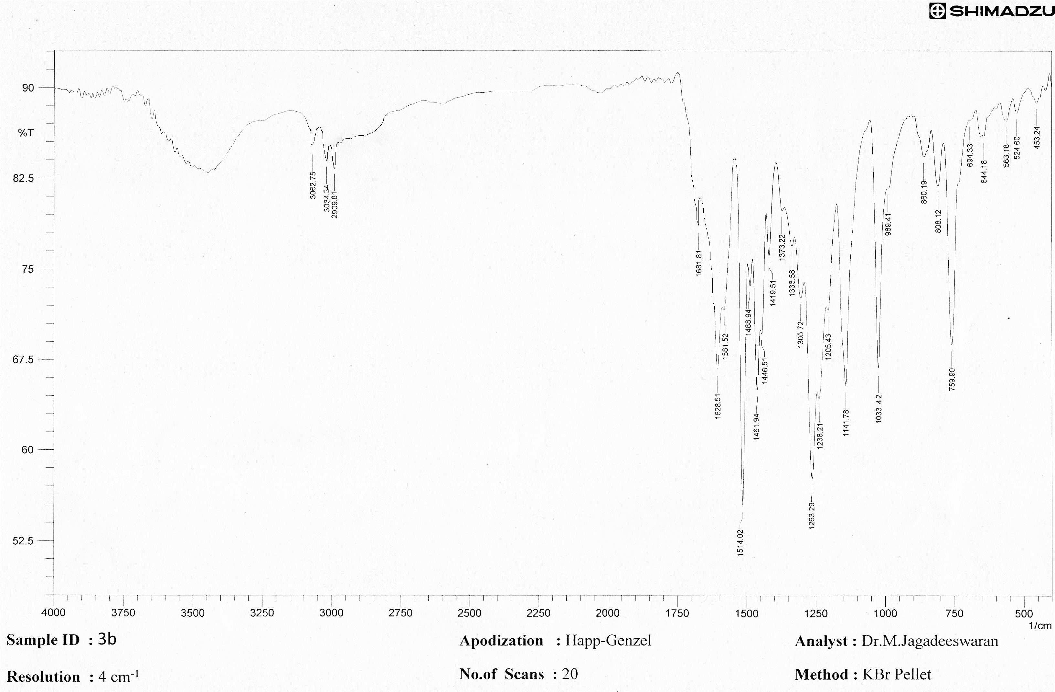

COMPOUND 3e
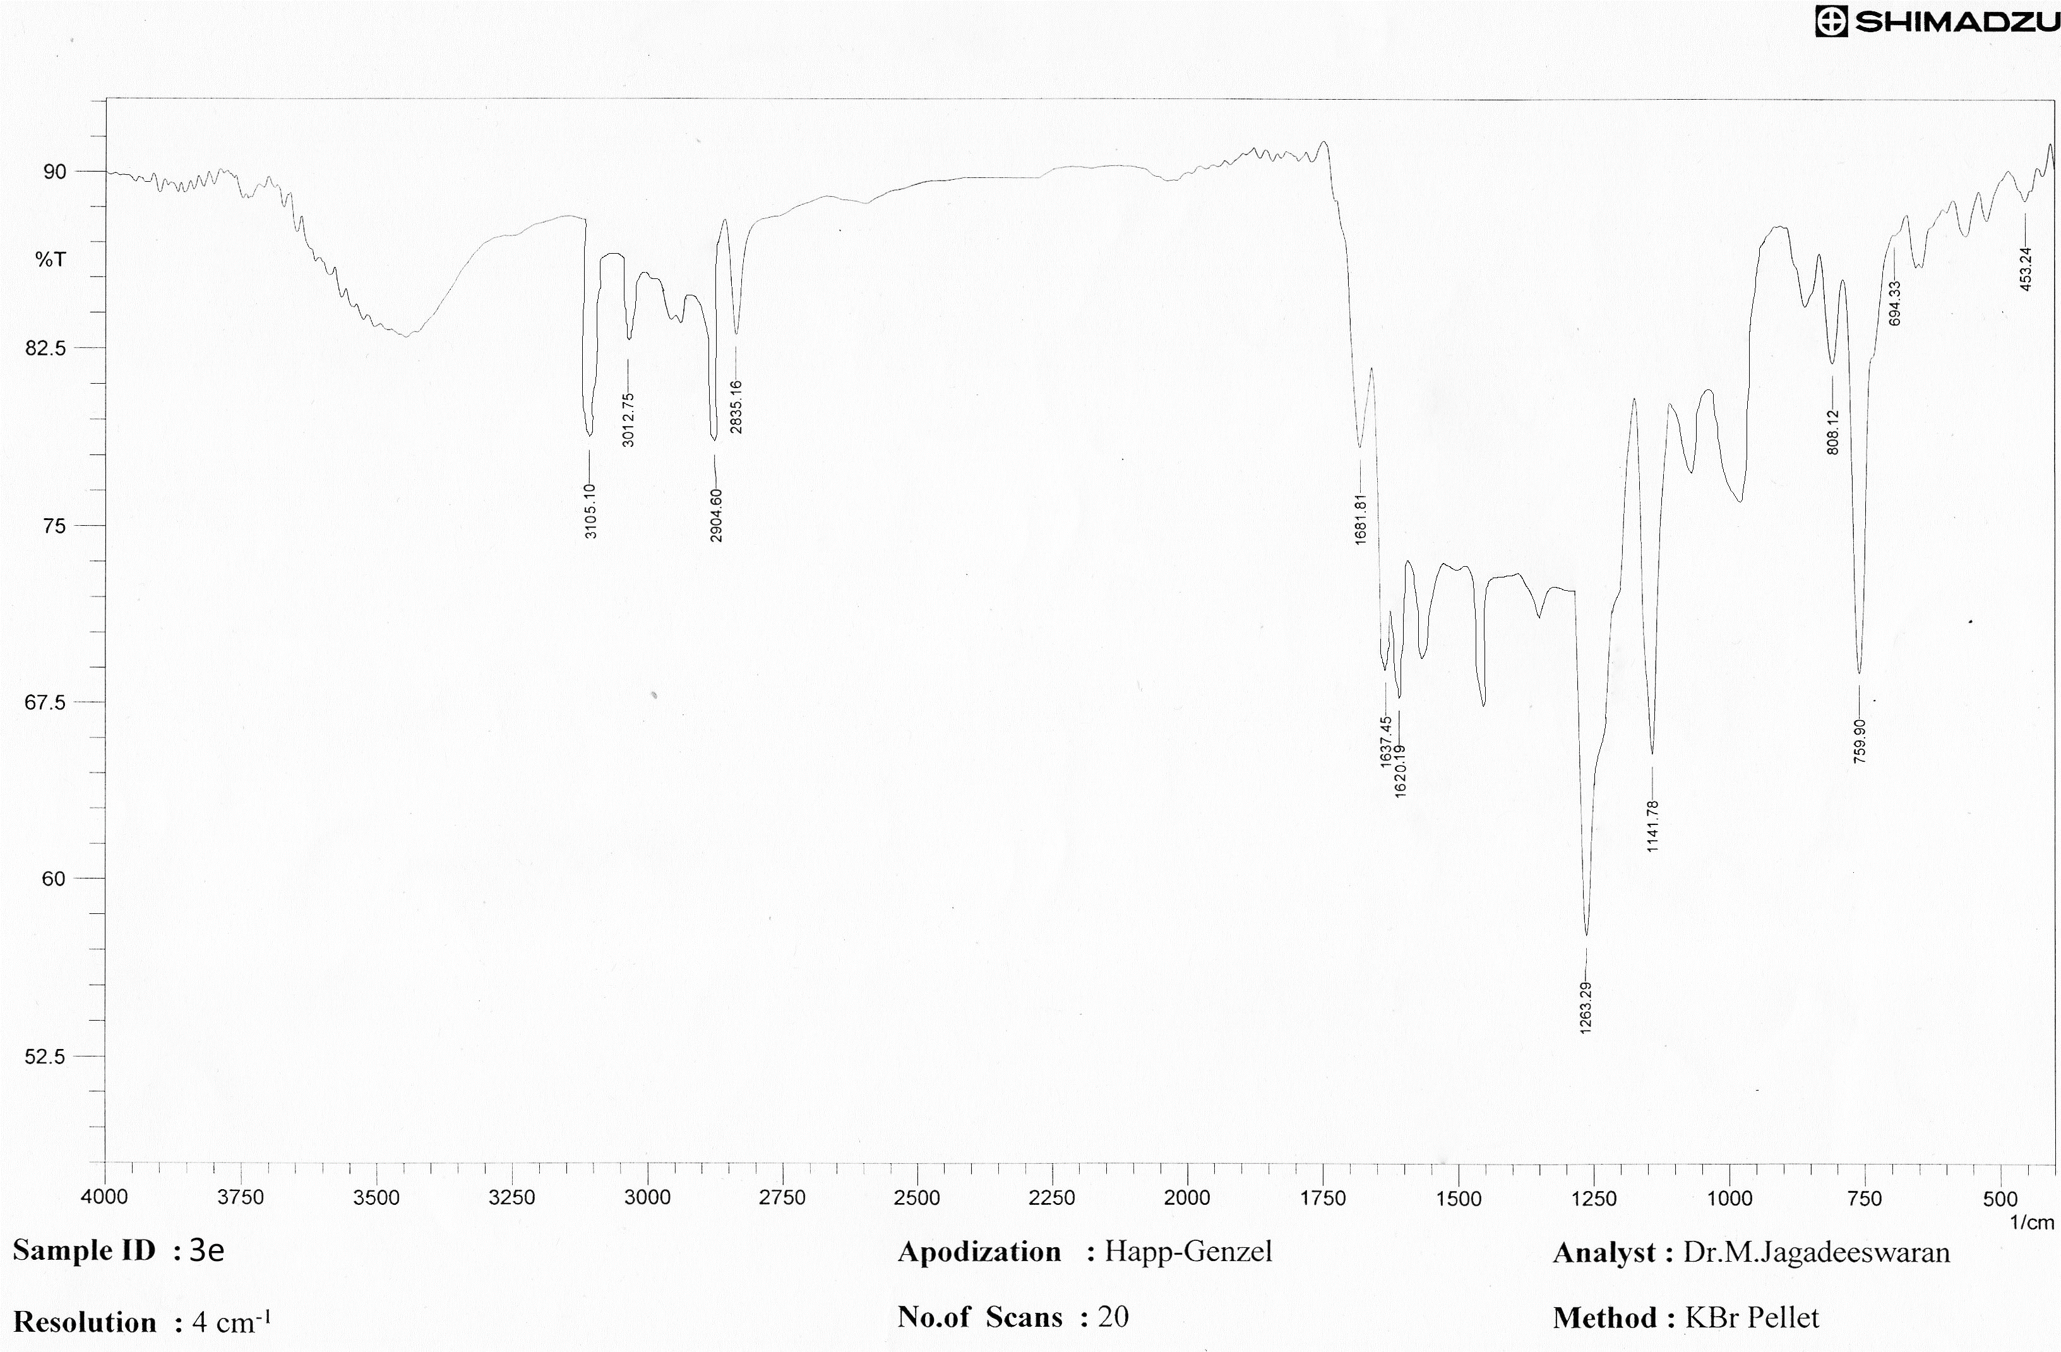

COMPOUND 3n
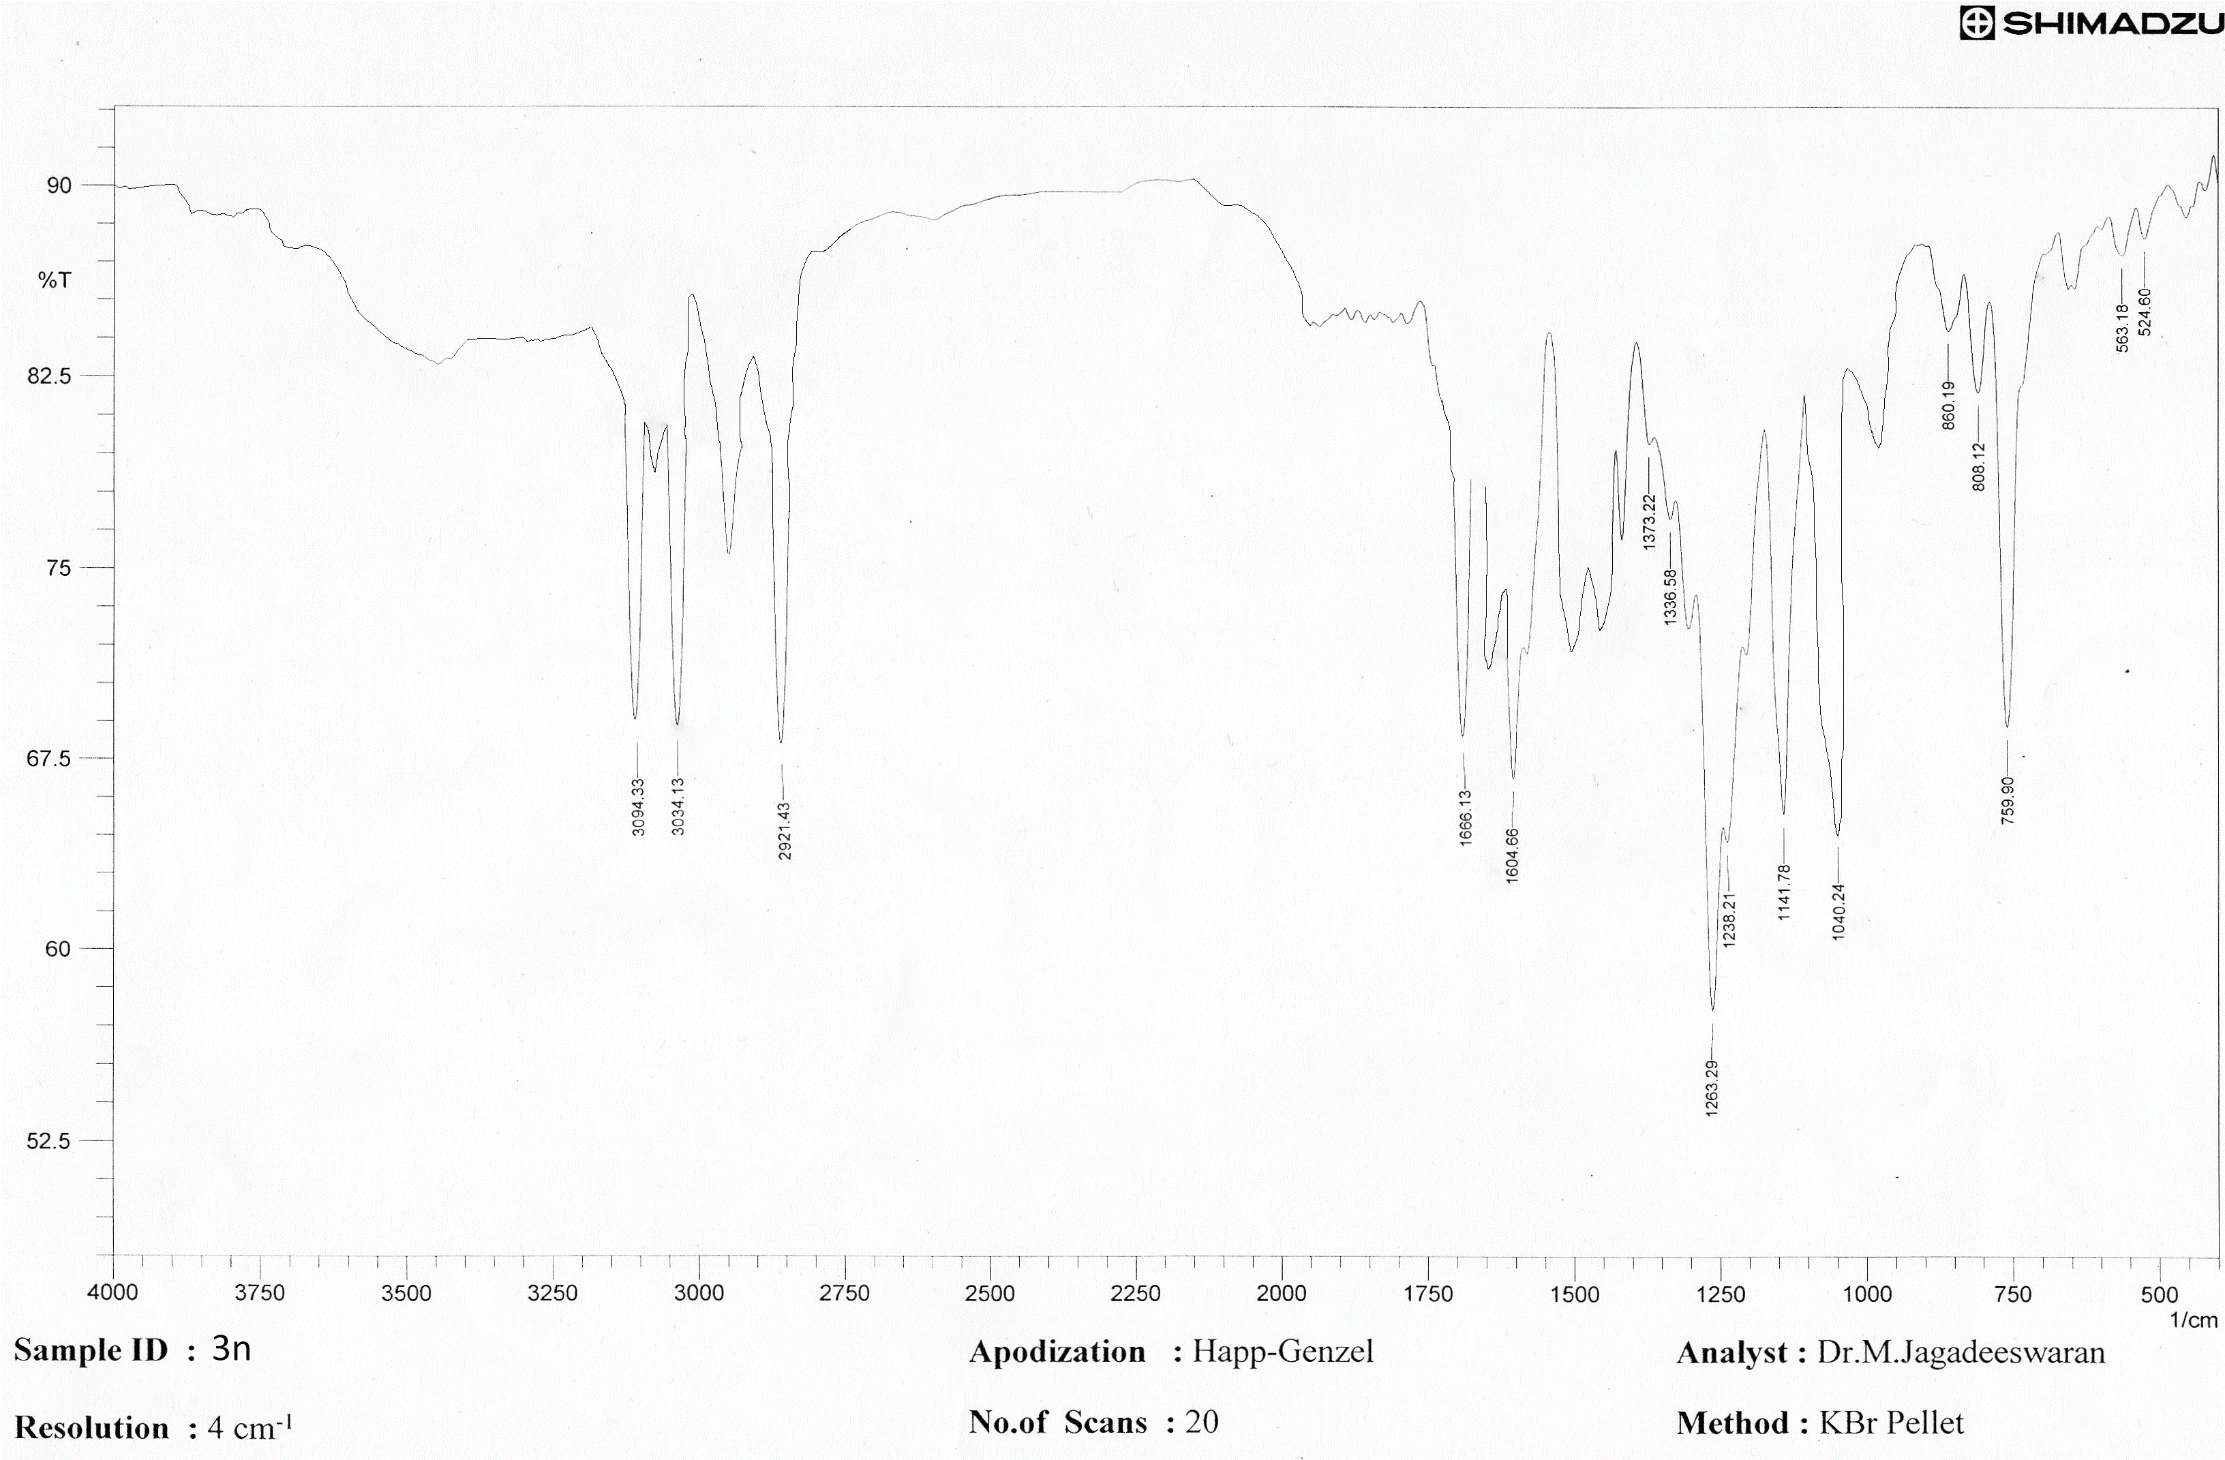
MASS SPECTRUM DETAILS
COMPOUND 3b
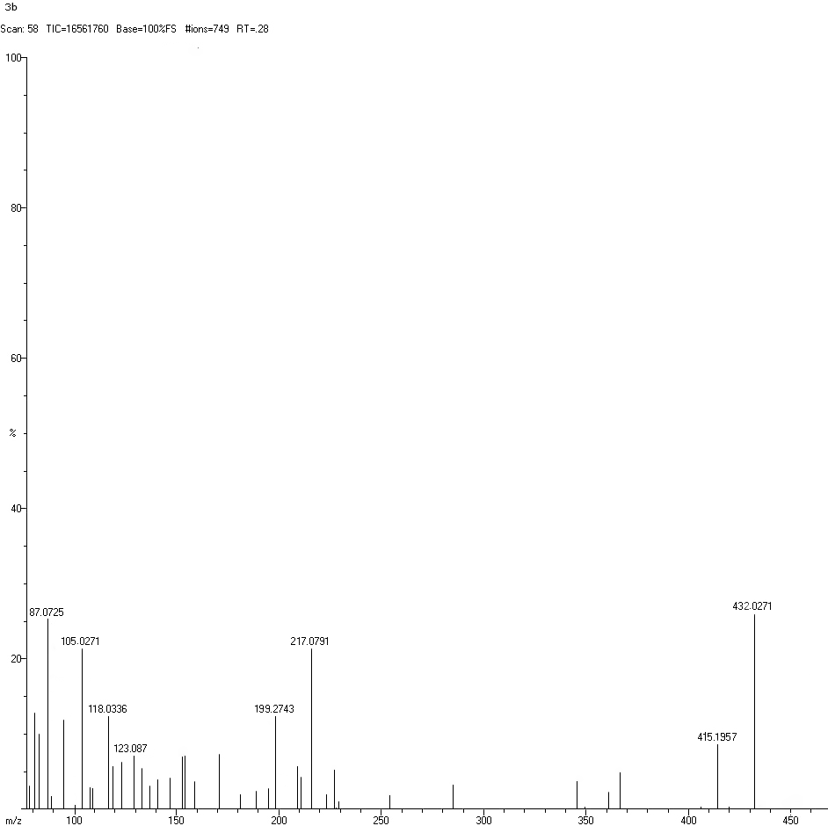

COMPOUND 3e
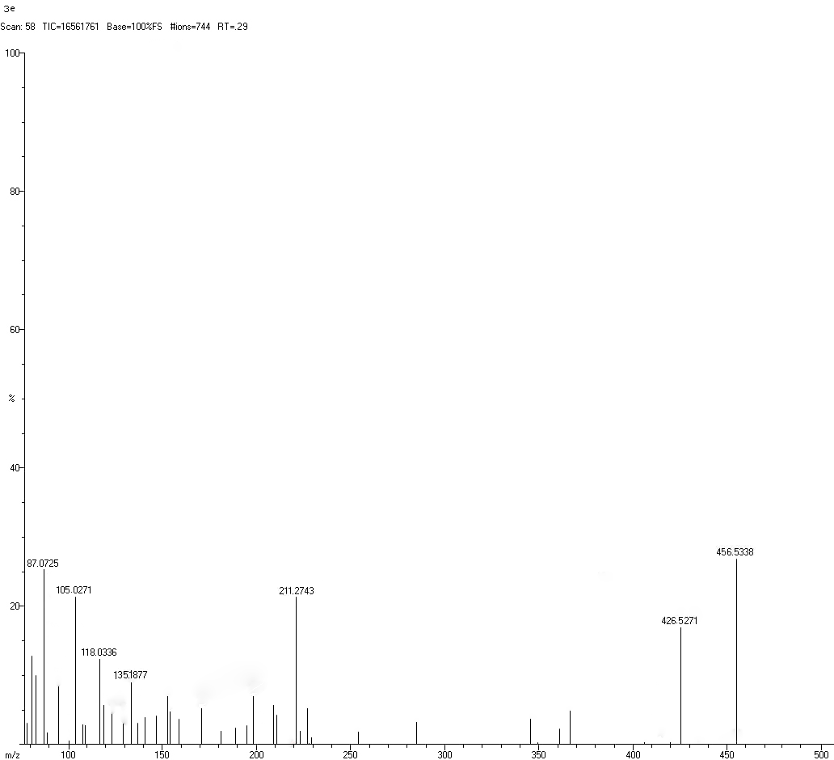

COMPOUND 3n
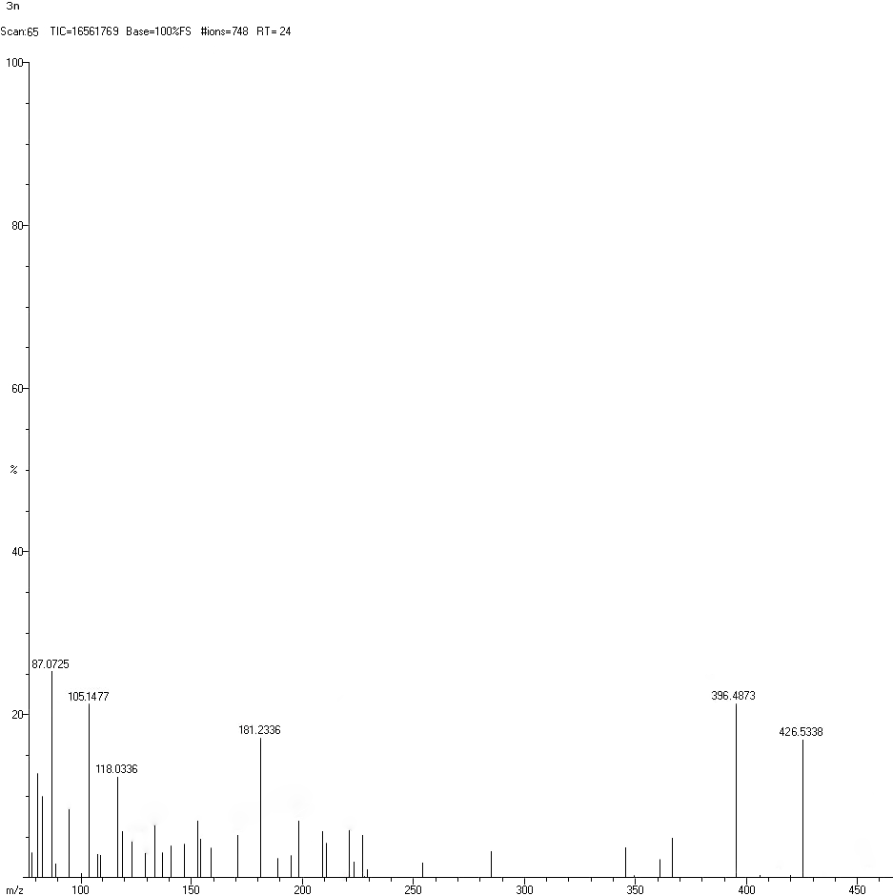
¹HNMR SPECTRUM DETAILS
COMPOUND 3a
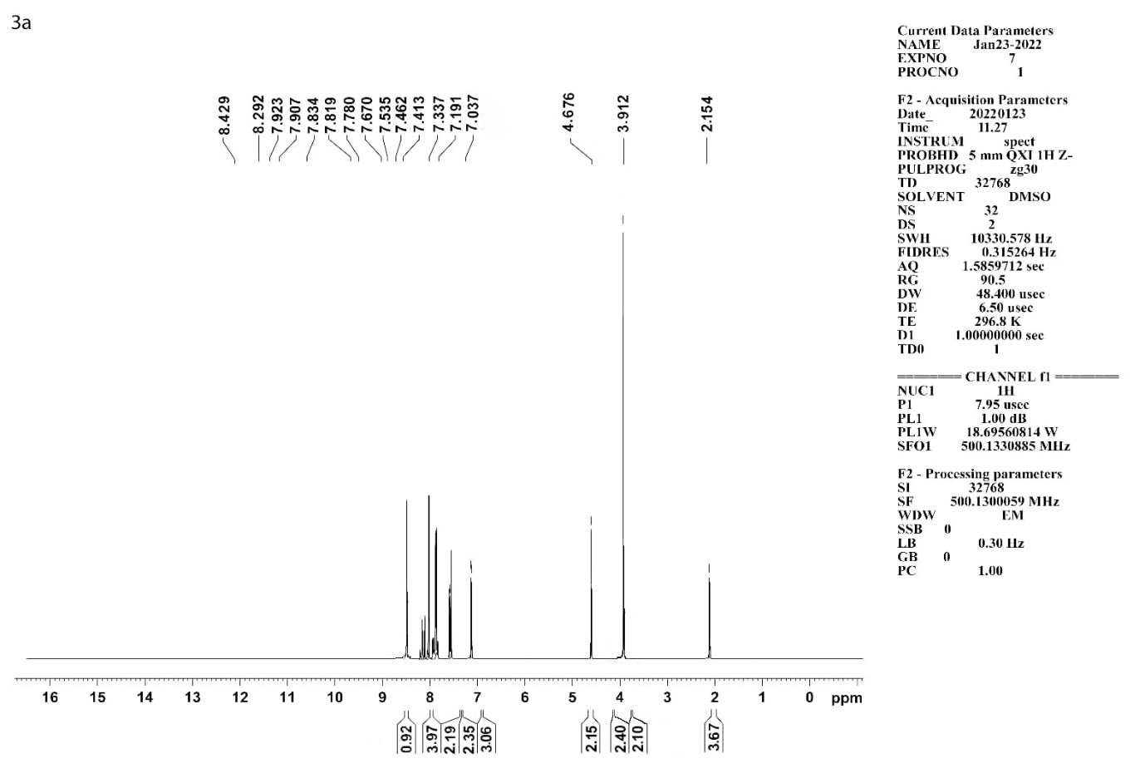
COMPOUND 3b
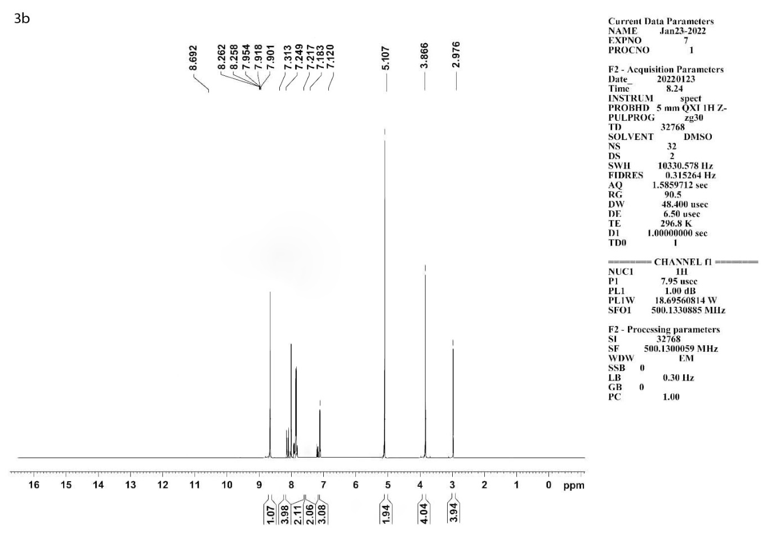
COMPOUND 3c
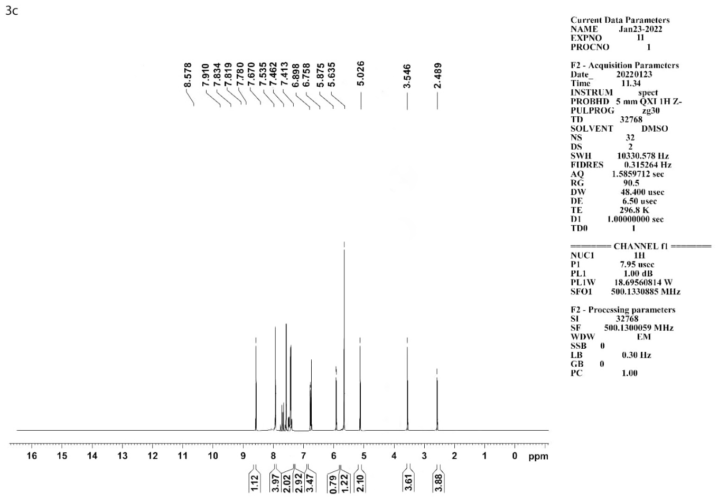
COMPOUND 3d
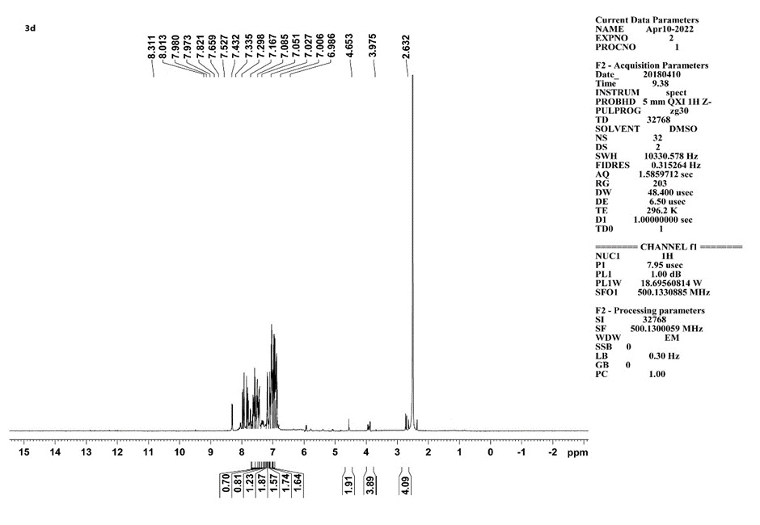
COMPOUND 3e
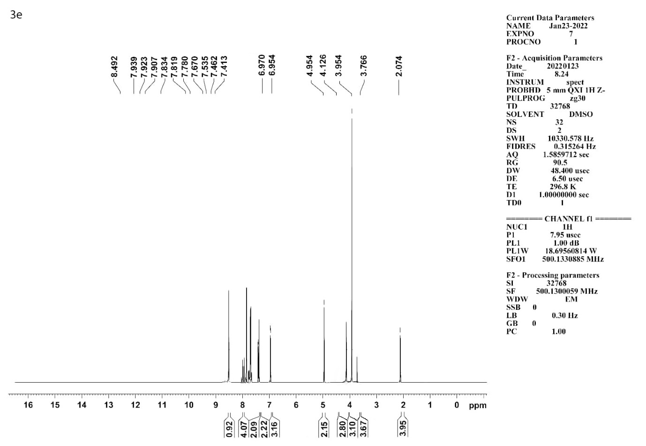
COMPOUND 3f
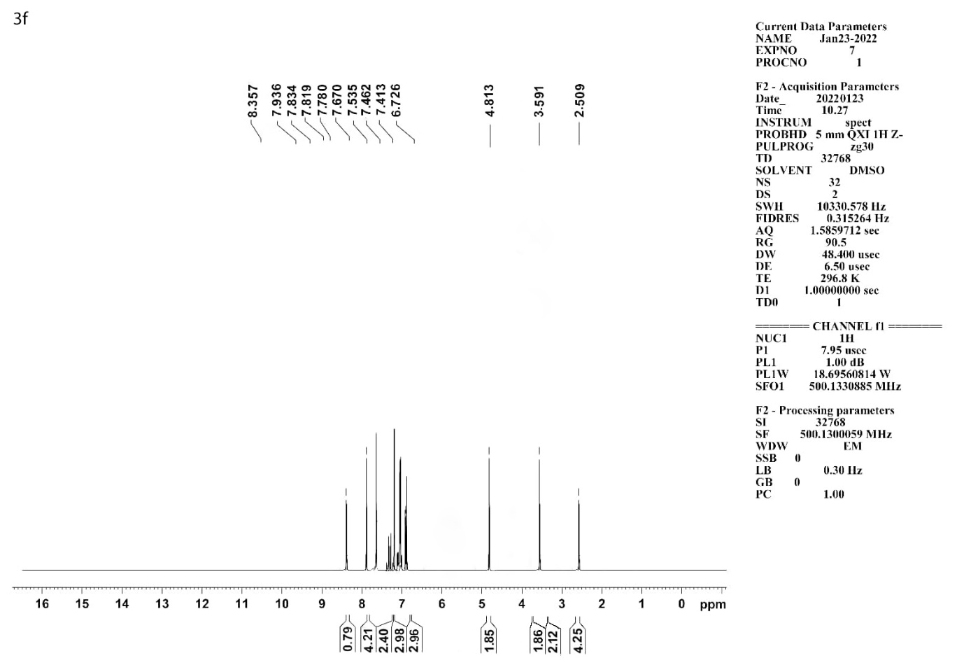
COMPOUND 3g
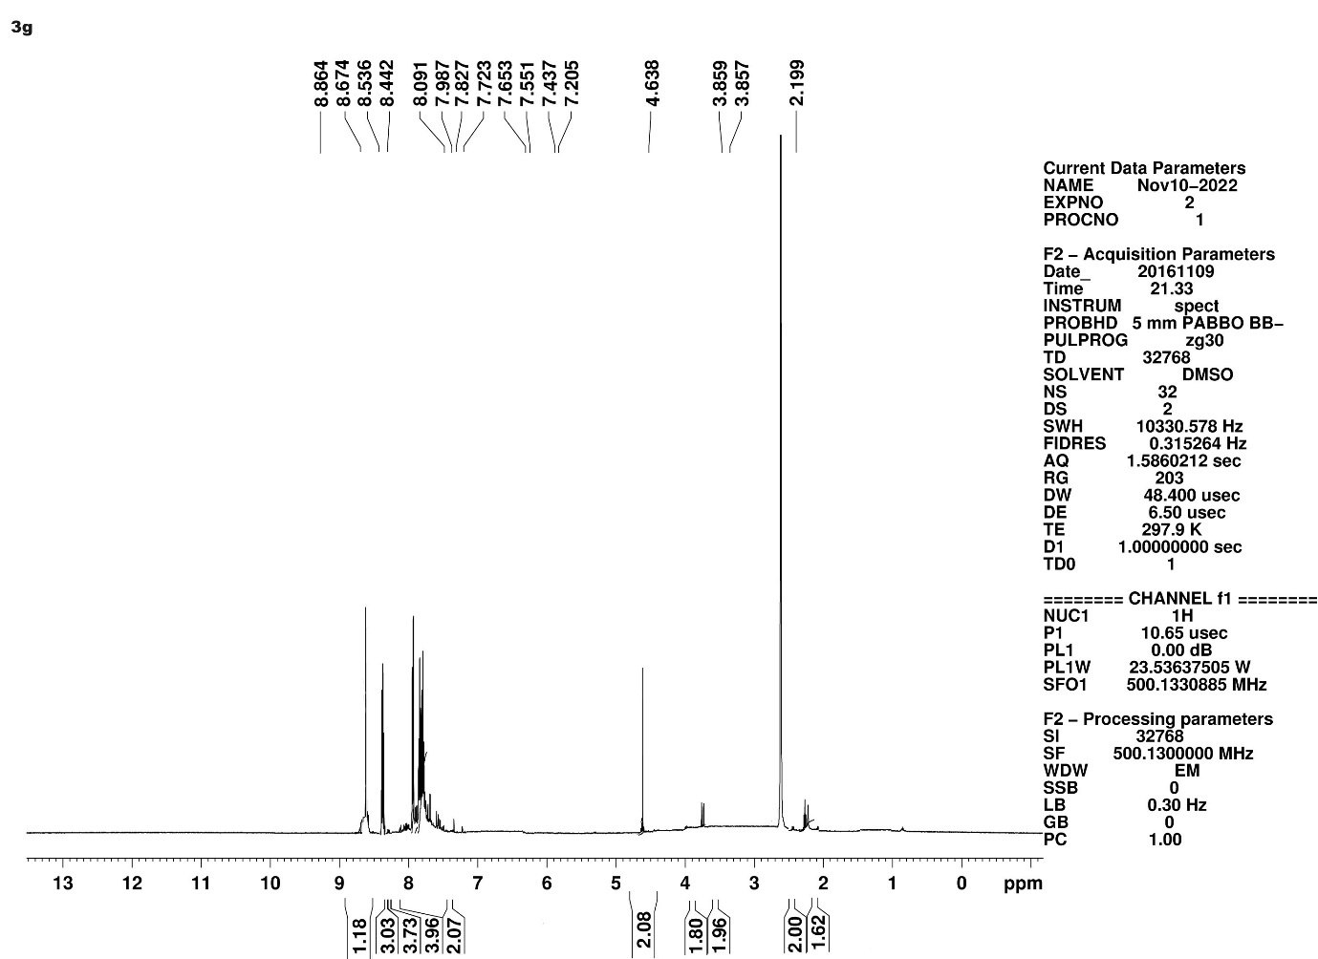
COMPOUND 3h
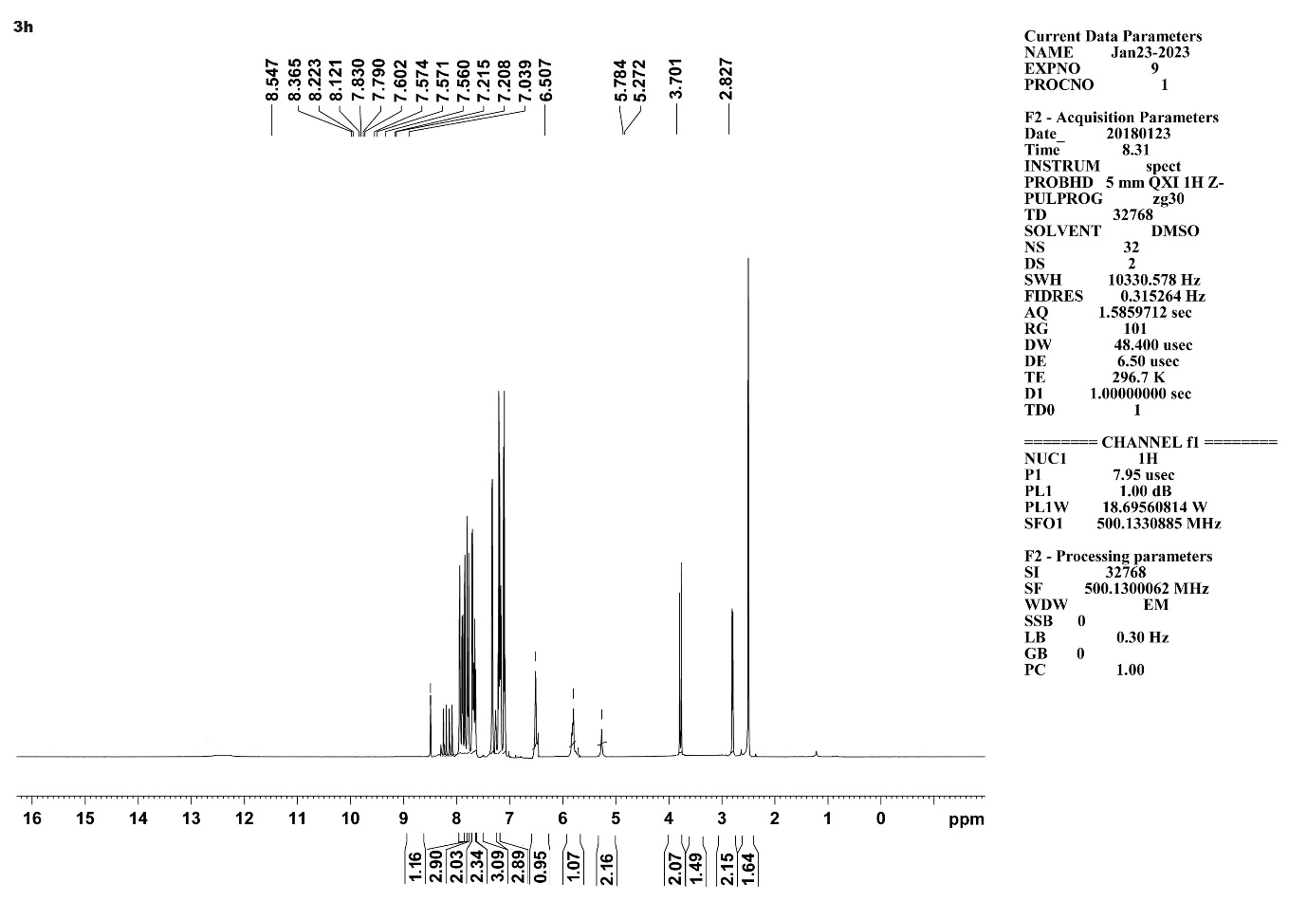
COMPOUND 3i
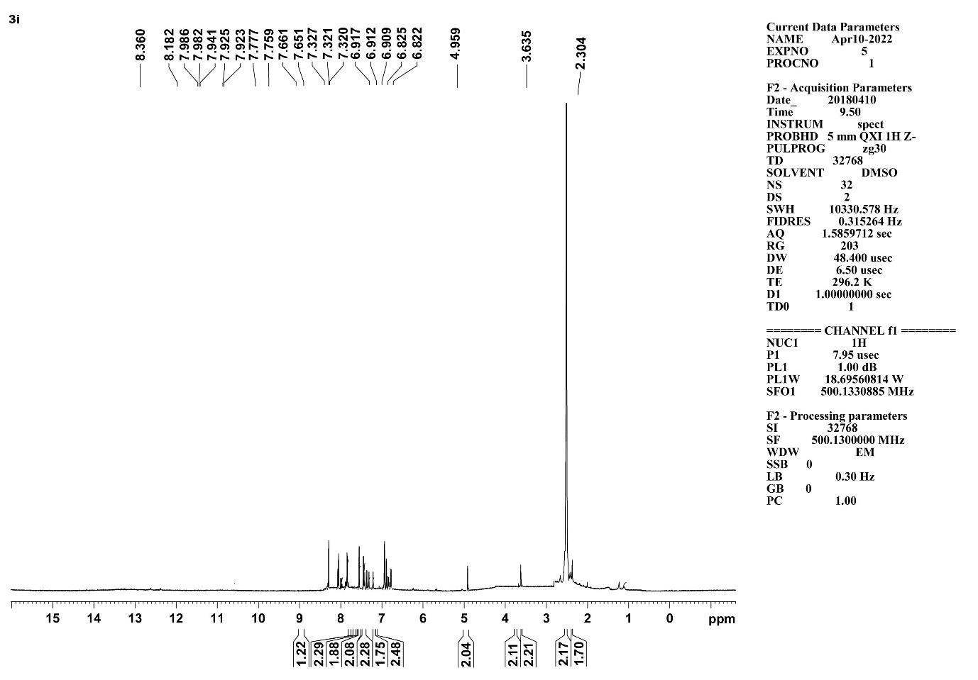
COMPOUND 3j
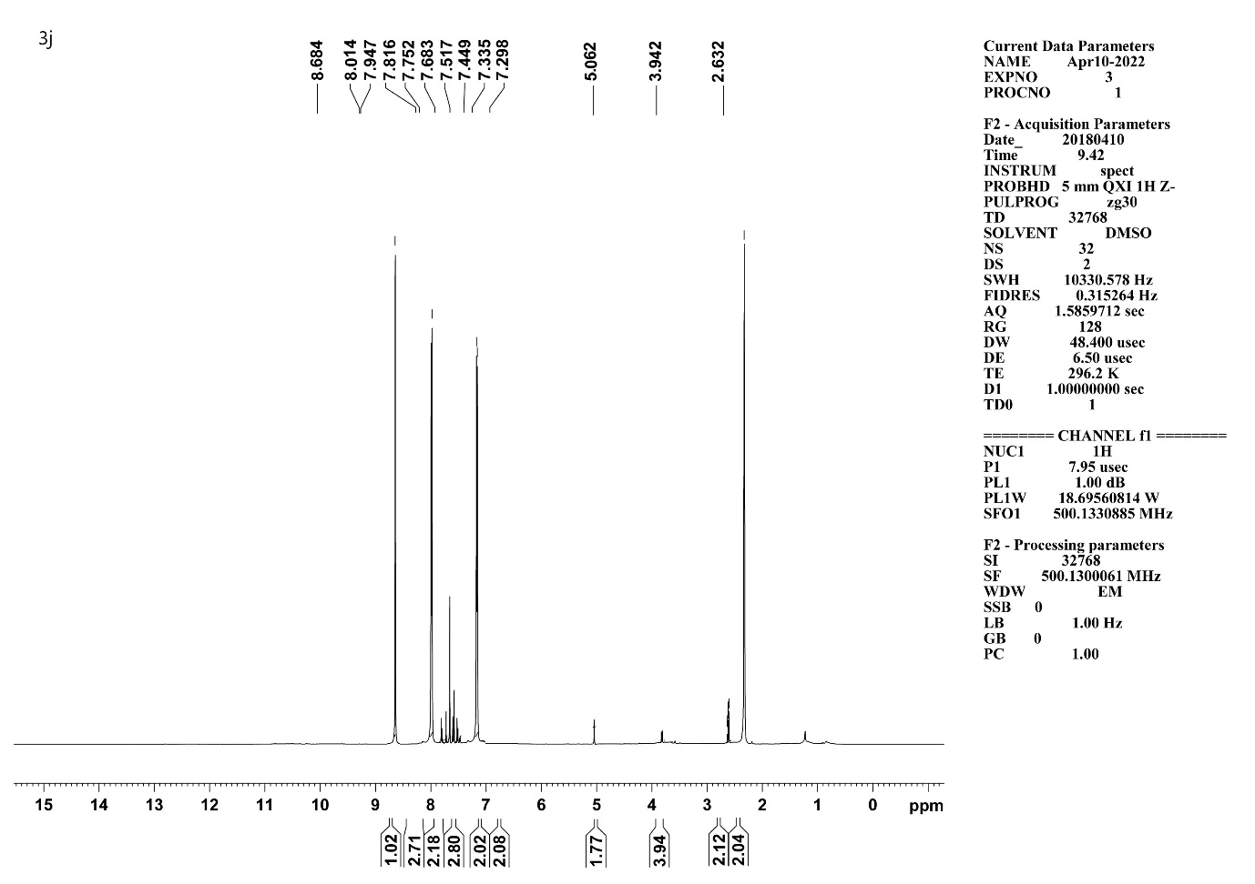
COMPOUND 3k
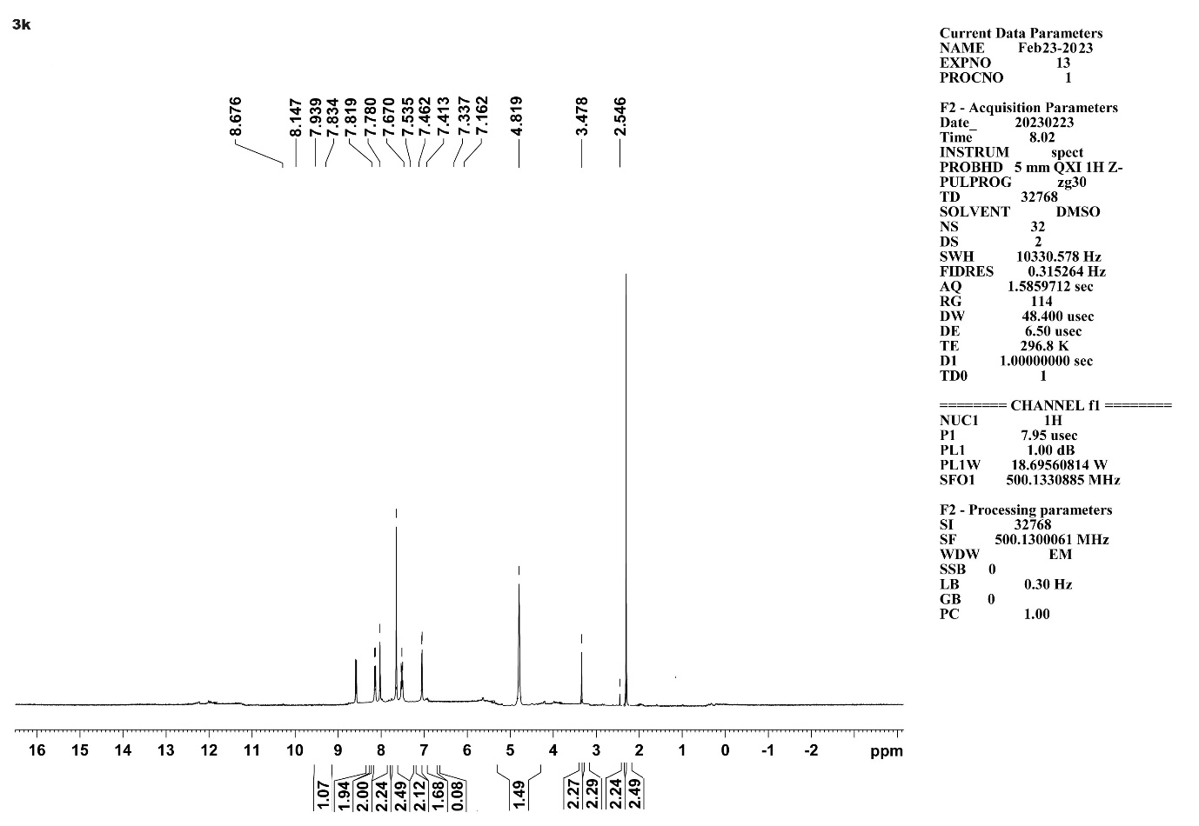
COMPOUND 3l
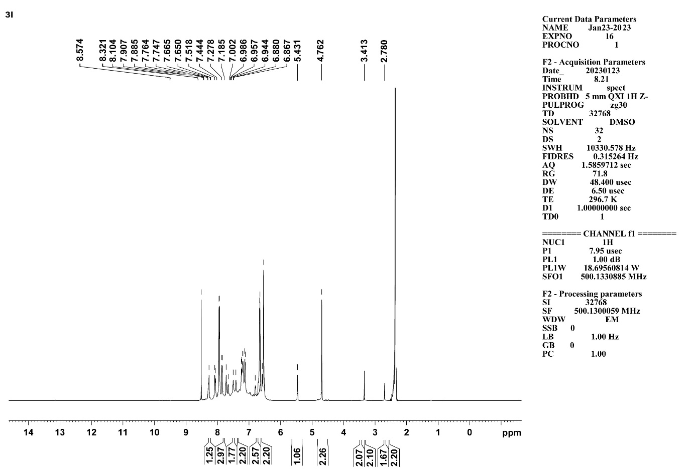
COMPOUND 3m
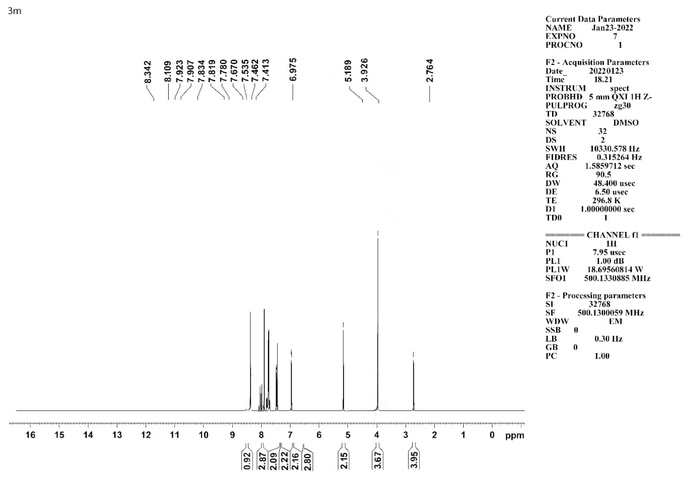
COMPOUND 3n
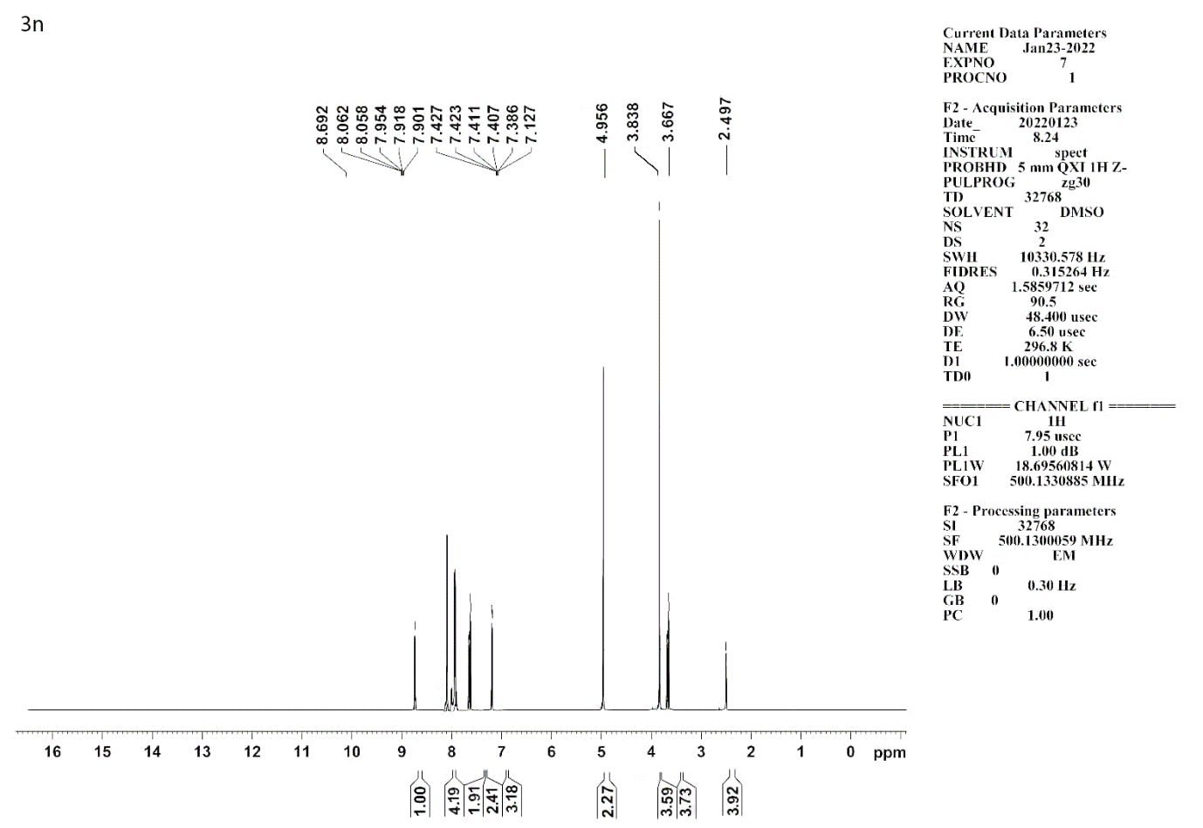
COMPOUND 3o
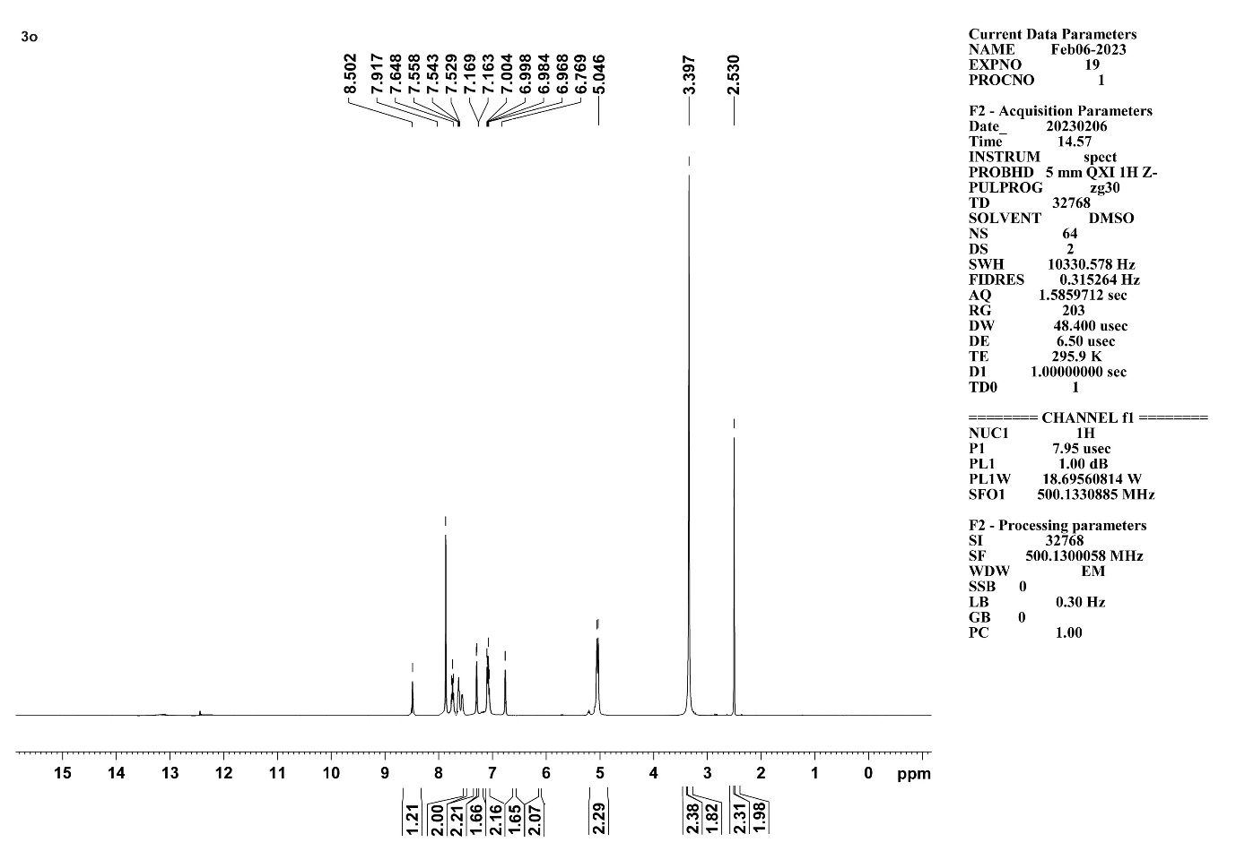
¹³CNMR SPECTRUM DETAILS
COMPOUND 3a
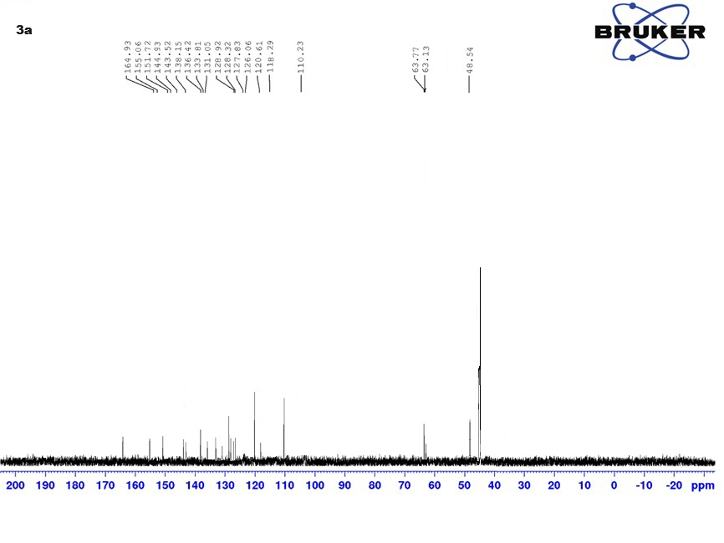

COMPOUND 3b
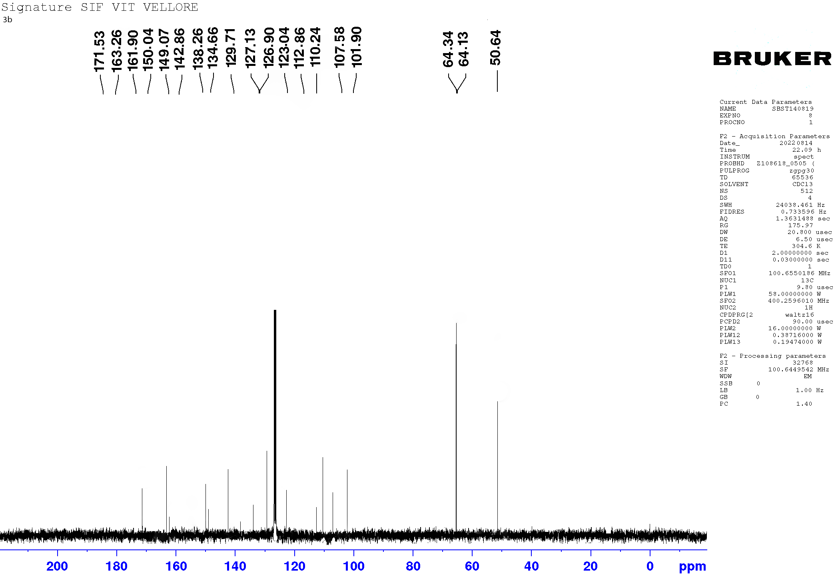
COMPOUND 3c
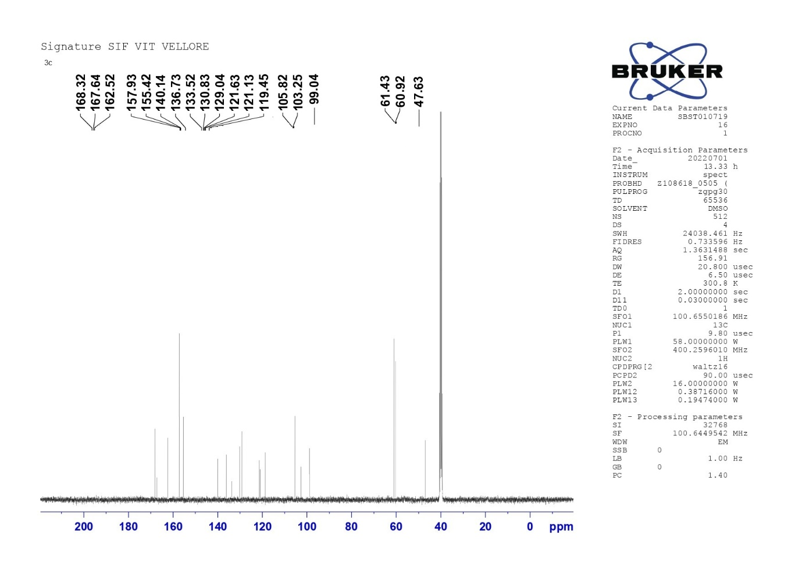

COMPOUND 3d
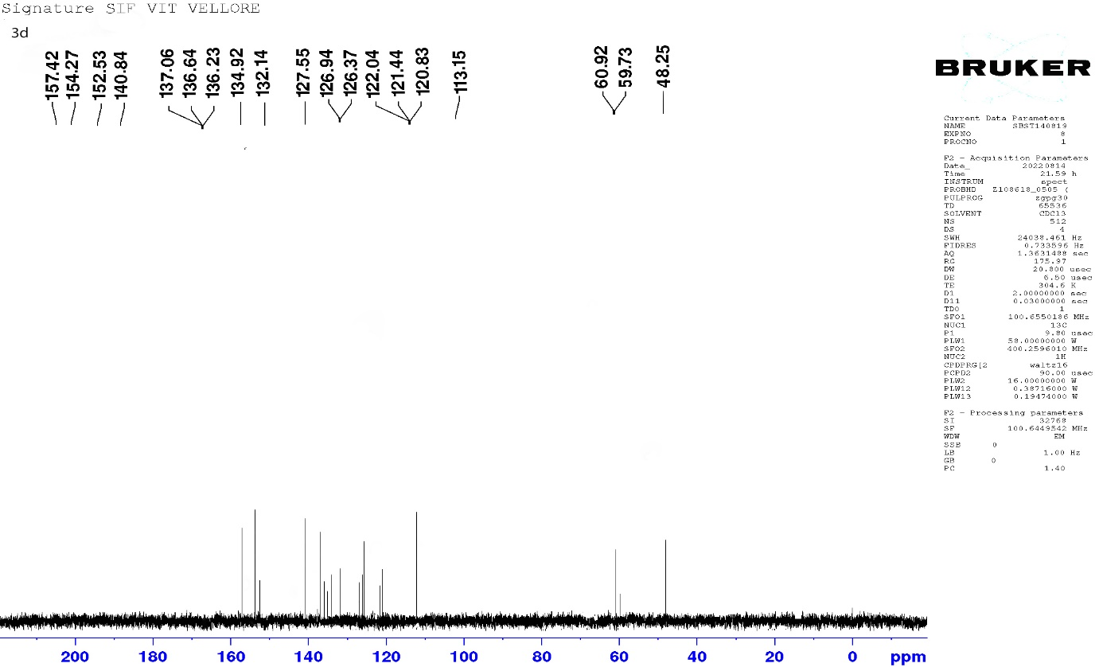

COMPOUND 3e
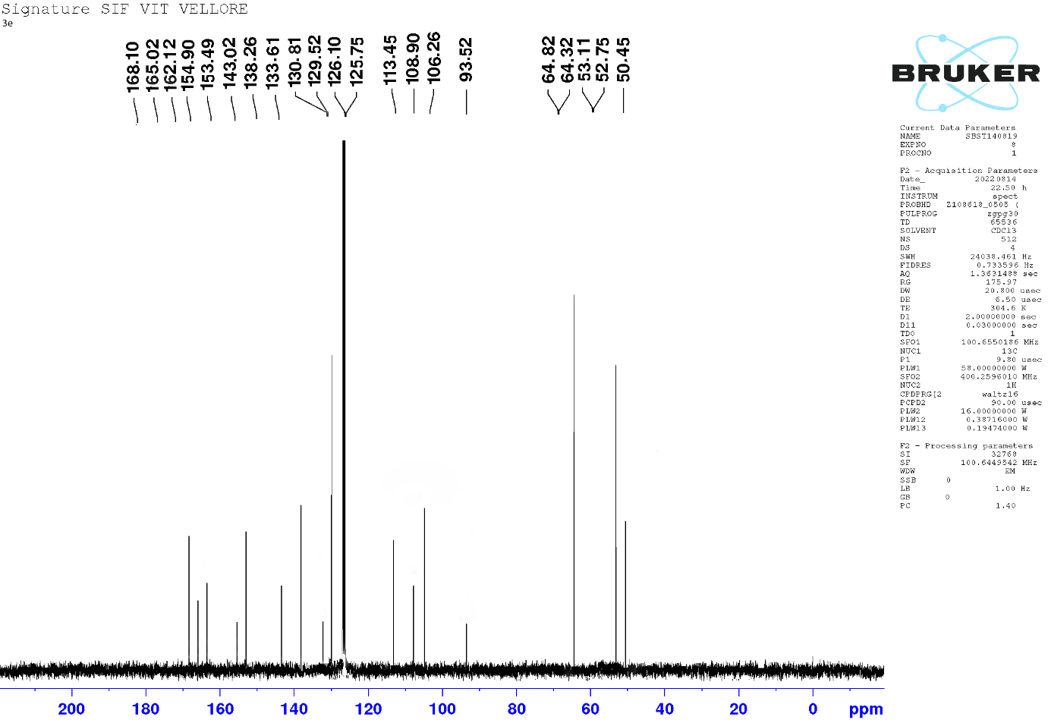
COMPOUND 3f
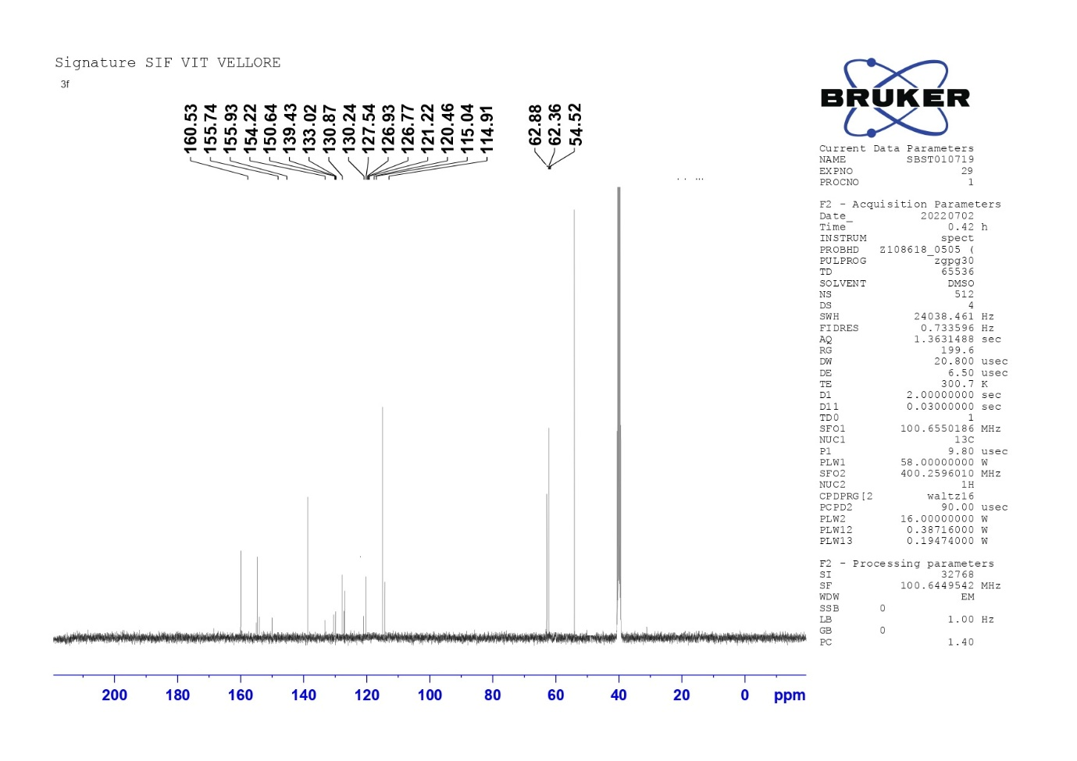
COMPOUND 3g
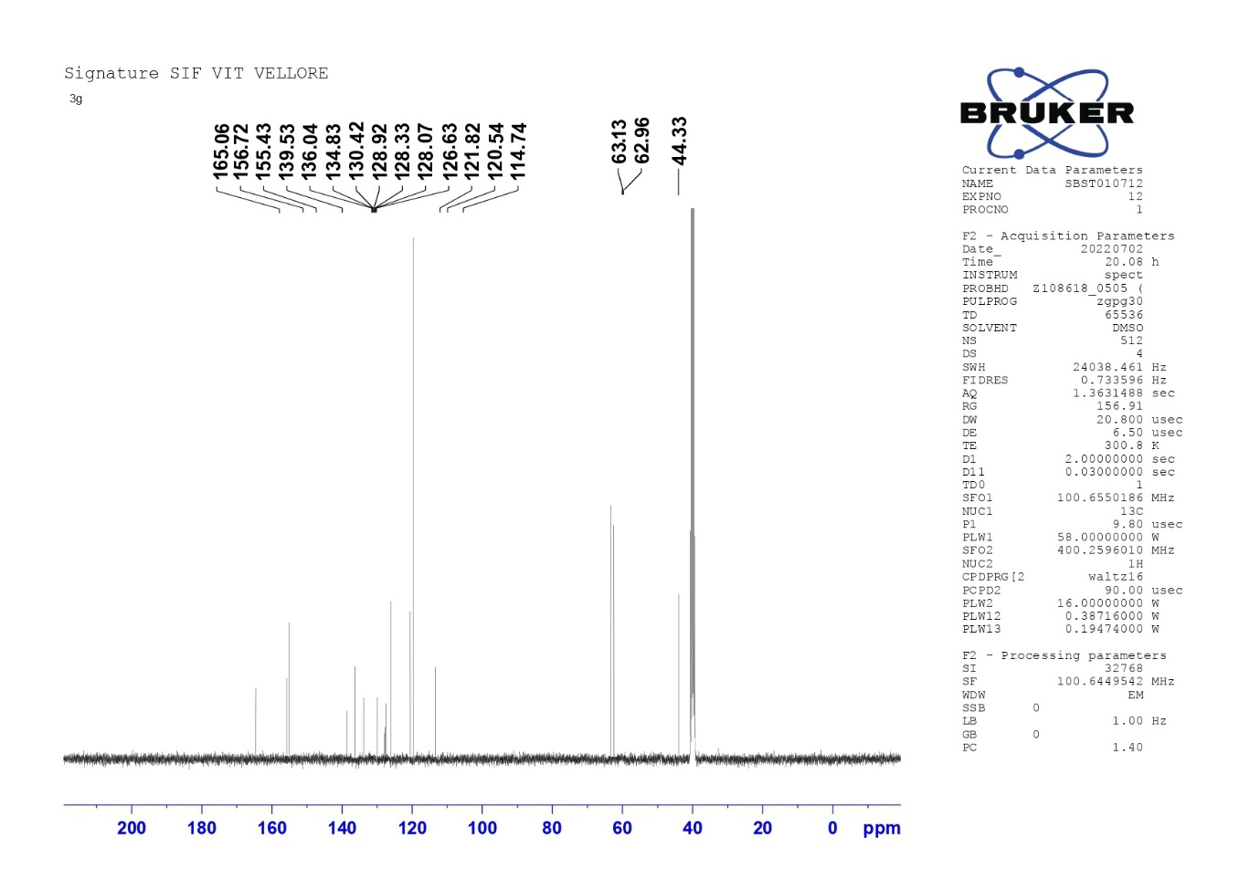
COMPOUND 3h
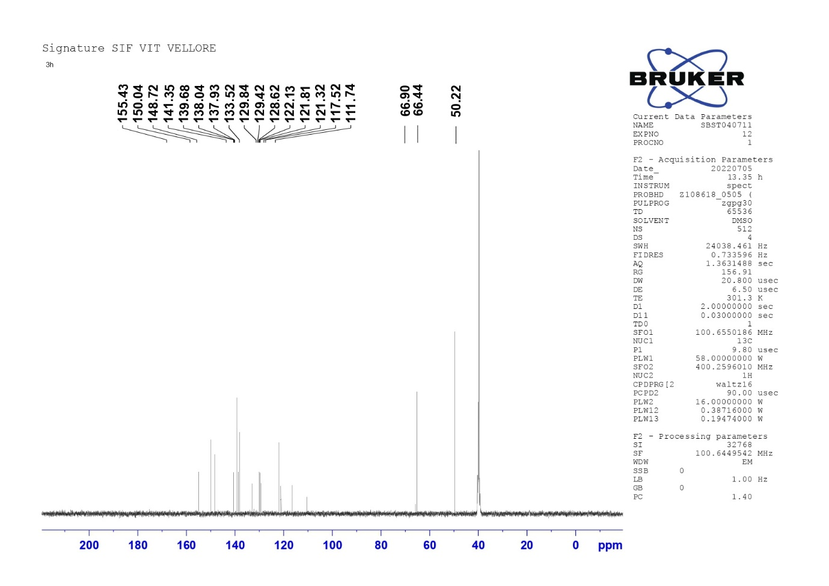
COMPOUND 3i
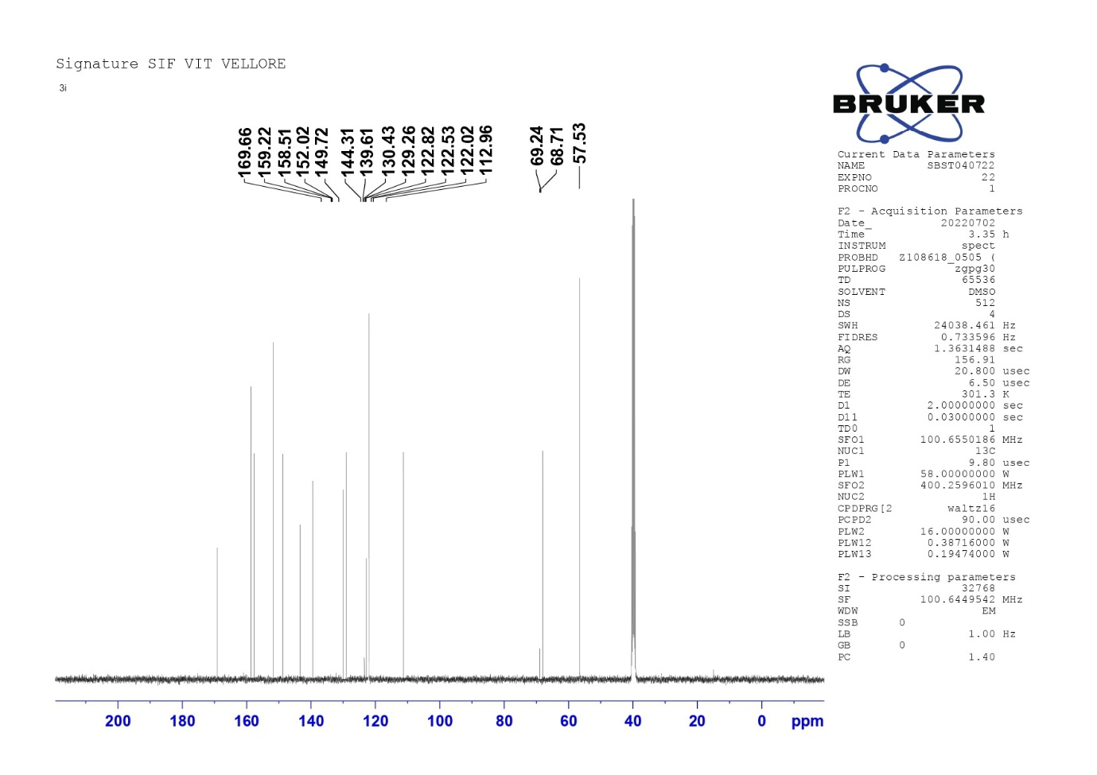
COMPOUND 3j
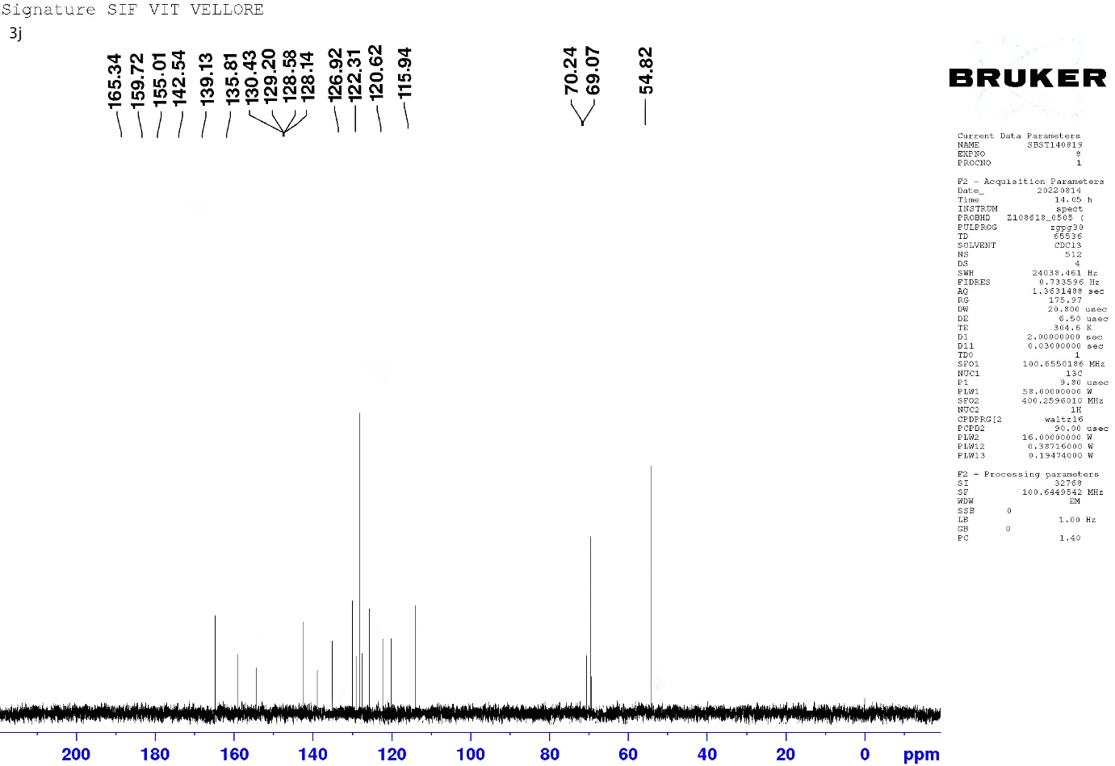
COMPOUND 3k
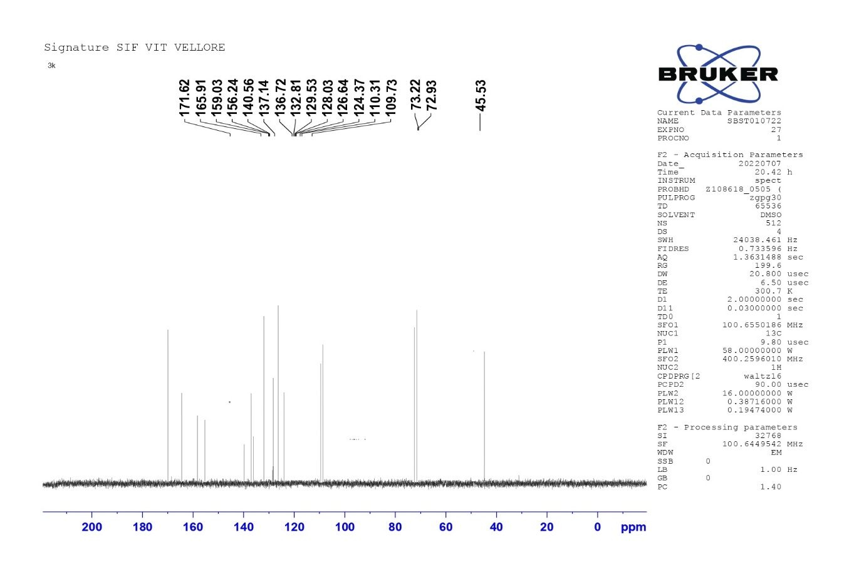

COMPOUND 3l
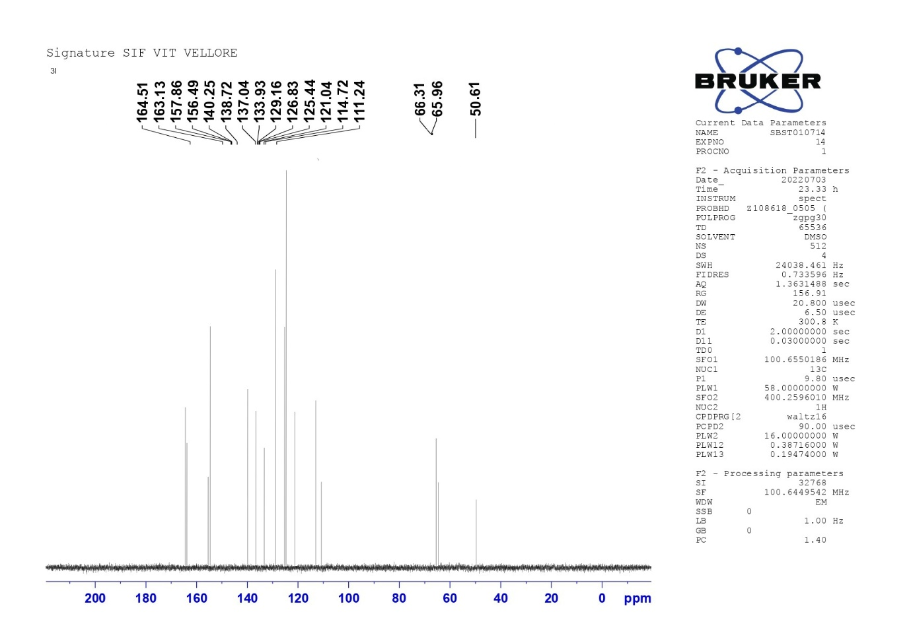
COMPOUND 3m
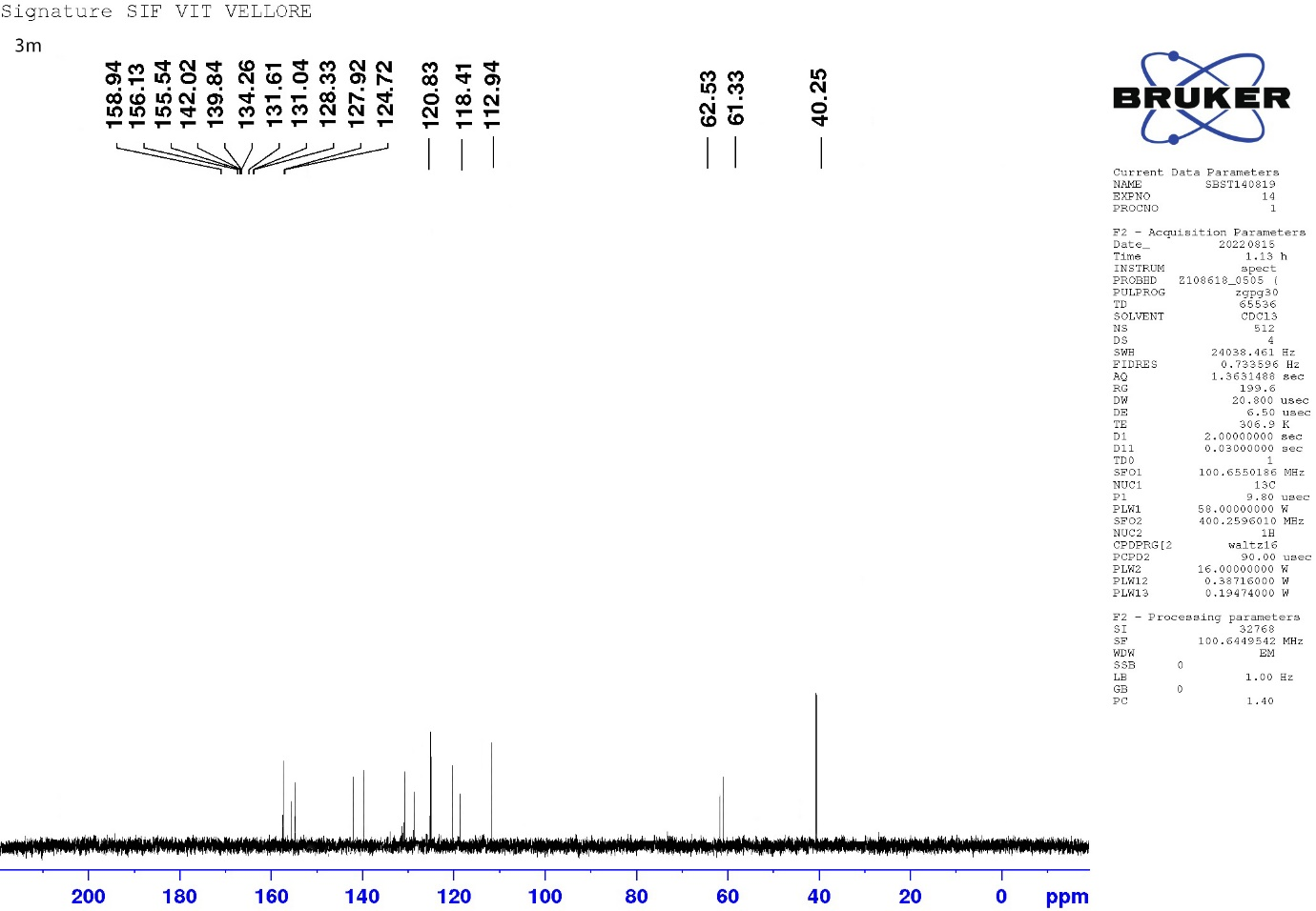
COMPOUND 3n
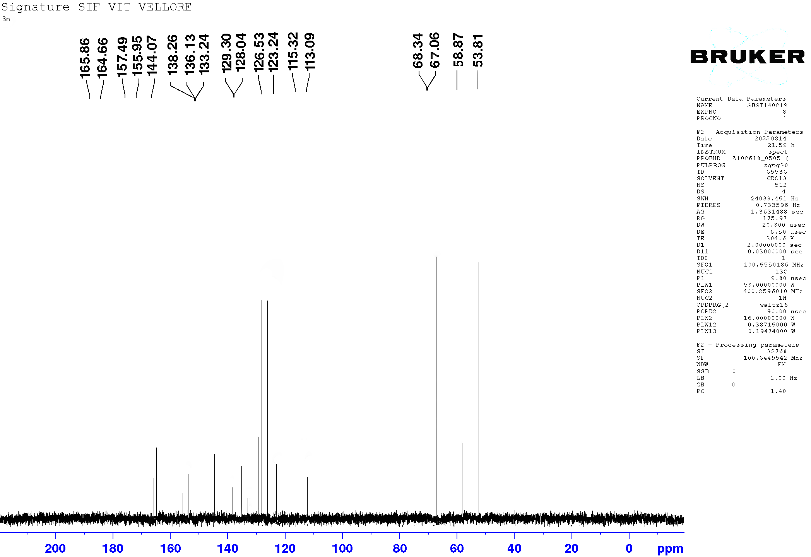
COMPOUND 3o
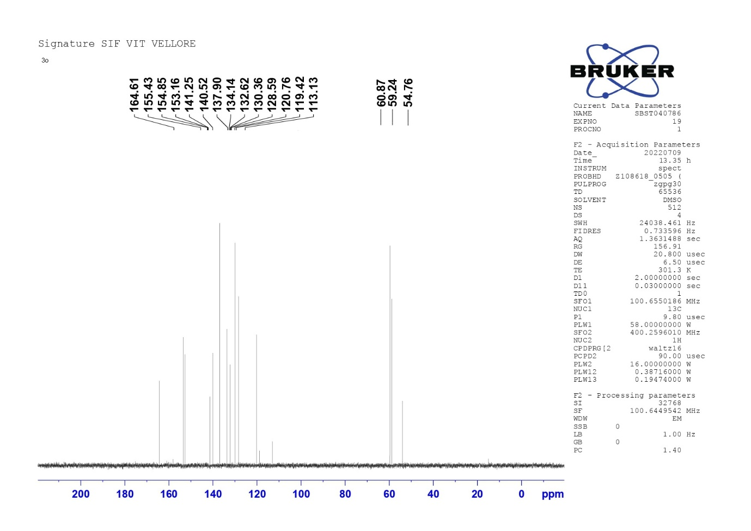
Supplementary figures: Selected images for Anti-microbial activity
